A comparison of heat flow interpolation techniques

# Introduction

Heat escaping the solid Earth’s surface indicates a dynamically cooling planet. Surface heat flow databases (Hasterok & Chapman, 2008; Lucazeau, 2019; Pollack et al., 1993) provide a way to investigate and quantify geodynamics by relating the amount of heat escaping Earth’s surface to heat-transferring and heat-generating subsurface processes such as diffusion, hydrothermal circulation, radioactive decay, fault motion, subduction dynamics, and mantle convection (Currie et al., 2004; Currie & Hyndman, 2006; Fourier, 1827; Furlong & Chapman, 2013; Furukawa, 1993; Gao & Wang, 2014; Hasterok, 2013; Kerswell et al., 2020; Parsons & Sclater, 1977; Pollack & Chapman, 1977; Rudnick et al., 1998; Stein & Stein, 1992, 1994; Wada & Wang, 2009). Surface heat flow observations continue to motivate research, evident by more than 1,393 publications compiled in the most recent heat flow dataset, although the rate of publications using surface heat flow has declined since the mid 1980’s (Jennings & Hasterok, 2021).

Questions such as calculating the global surface heat flux from continents and oceans require interpolating discrete heat flow observations onto a continuous approximation of Earth’s surface. Interpolation attempts commonly use one or more geographic, geologic, geochronologic, or geophysical proxies to predict heat flow at unknown locations by association with similar observation sites (e.g., bathymetry or elevation, proximity to active or ancient orogens, seafloor age, upper mantle shear wave velocities, Chapman & Pollack, 1975; Davies, 2013; Goutorbe et al., 2011; Lee & Uyeda, 1965; Lucazeau, 2019; Sclater & Francheteau, 1970; Shapiro & Ritzwoller, 2004). These methods are called *similarity methods* (Figure 1) and follow the assumptions embedded in the Third Law of Geography: *the more similar the geographic configuration of two points, the more similar their values* (Zhu et al., 2018).

Using prior information in estimation is an advantage of the Third Law and is arguably the most reasonable approach for interpolating surface heat flow. Our understanding of geodynamics and near-surface heat flow perturbations implies a strong relationship between surface heat flow and the set of physical conditions (e.g., Goutorbe et al., 2011), irrespective of the location. For example, younger oceanic plates should have higher surface heat flow than older plates (Stein & Stein, 1992), subducting oceanic plates will lower surface heat flow near trenches (Furukawa, 1993), and hydrothermal circulation of seawater can modify heat escaping from oceanic crust (Hasterok et al., 2011). Interpolation by the Third Law makes reasoned predictions of heat flow with priors from many independently-tested geodynamic models. However, the Third Law is strongly biased towards such models and risk making determinations where, in fact, deviations from such models occur.

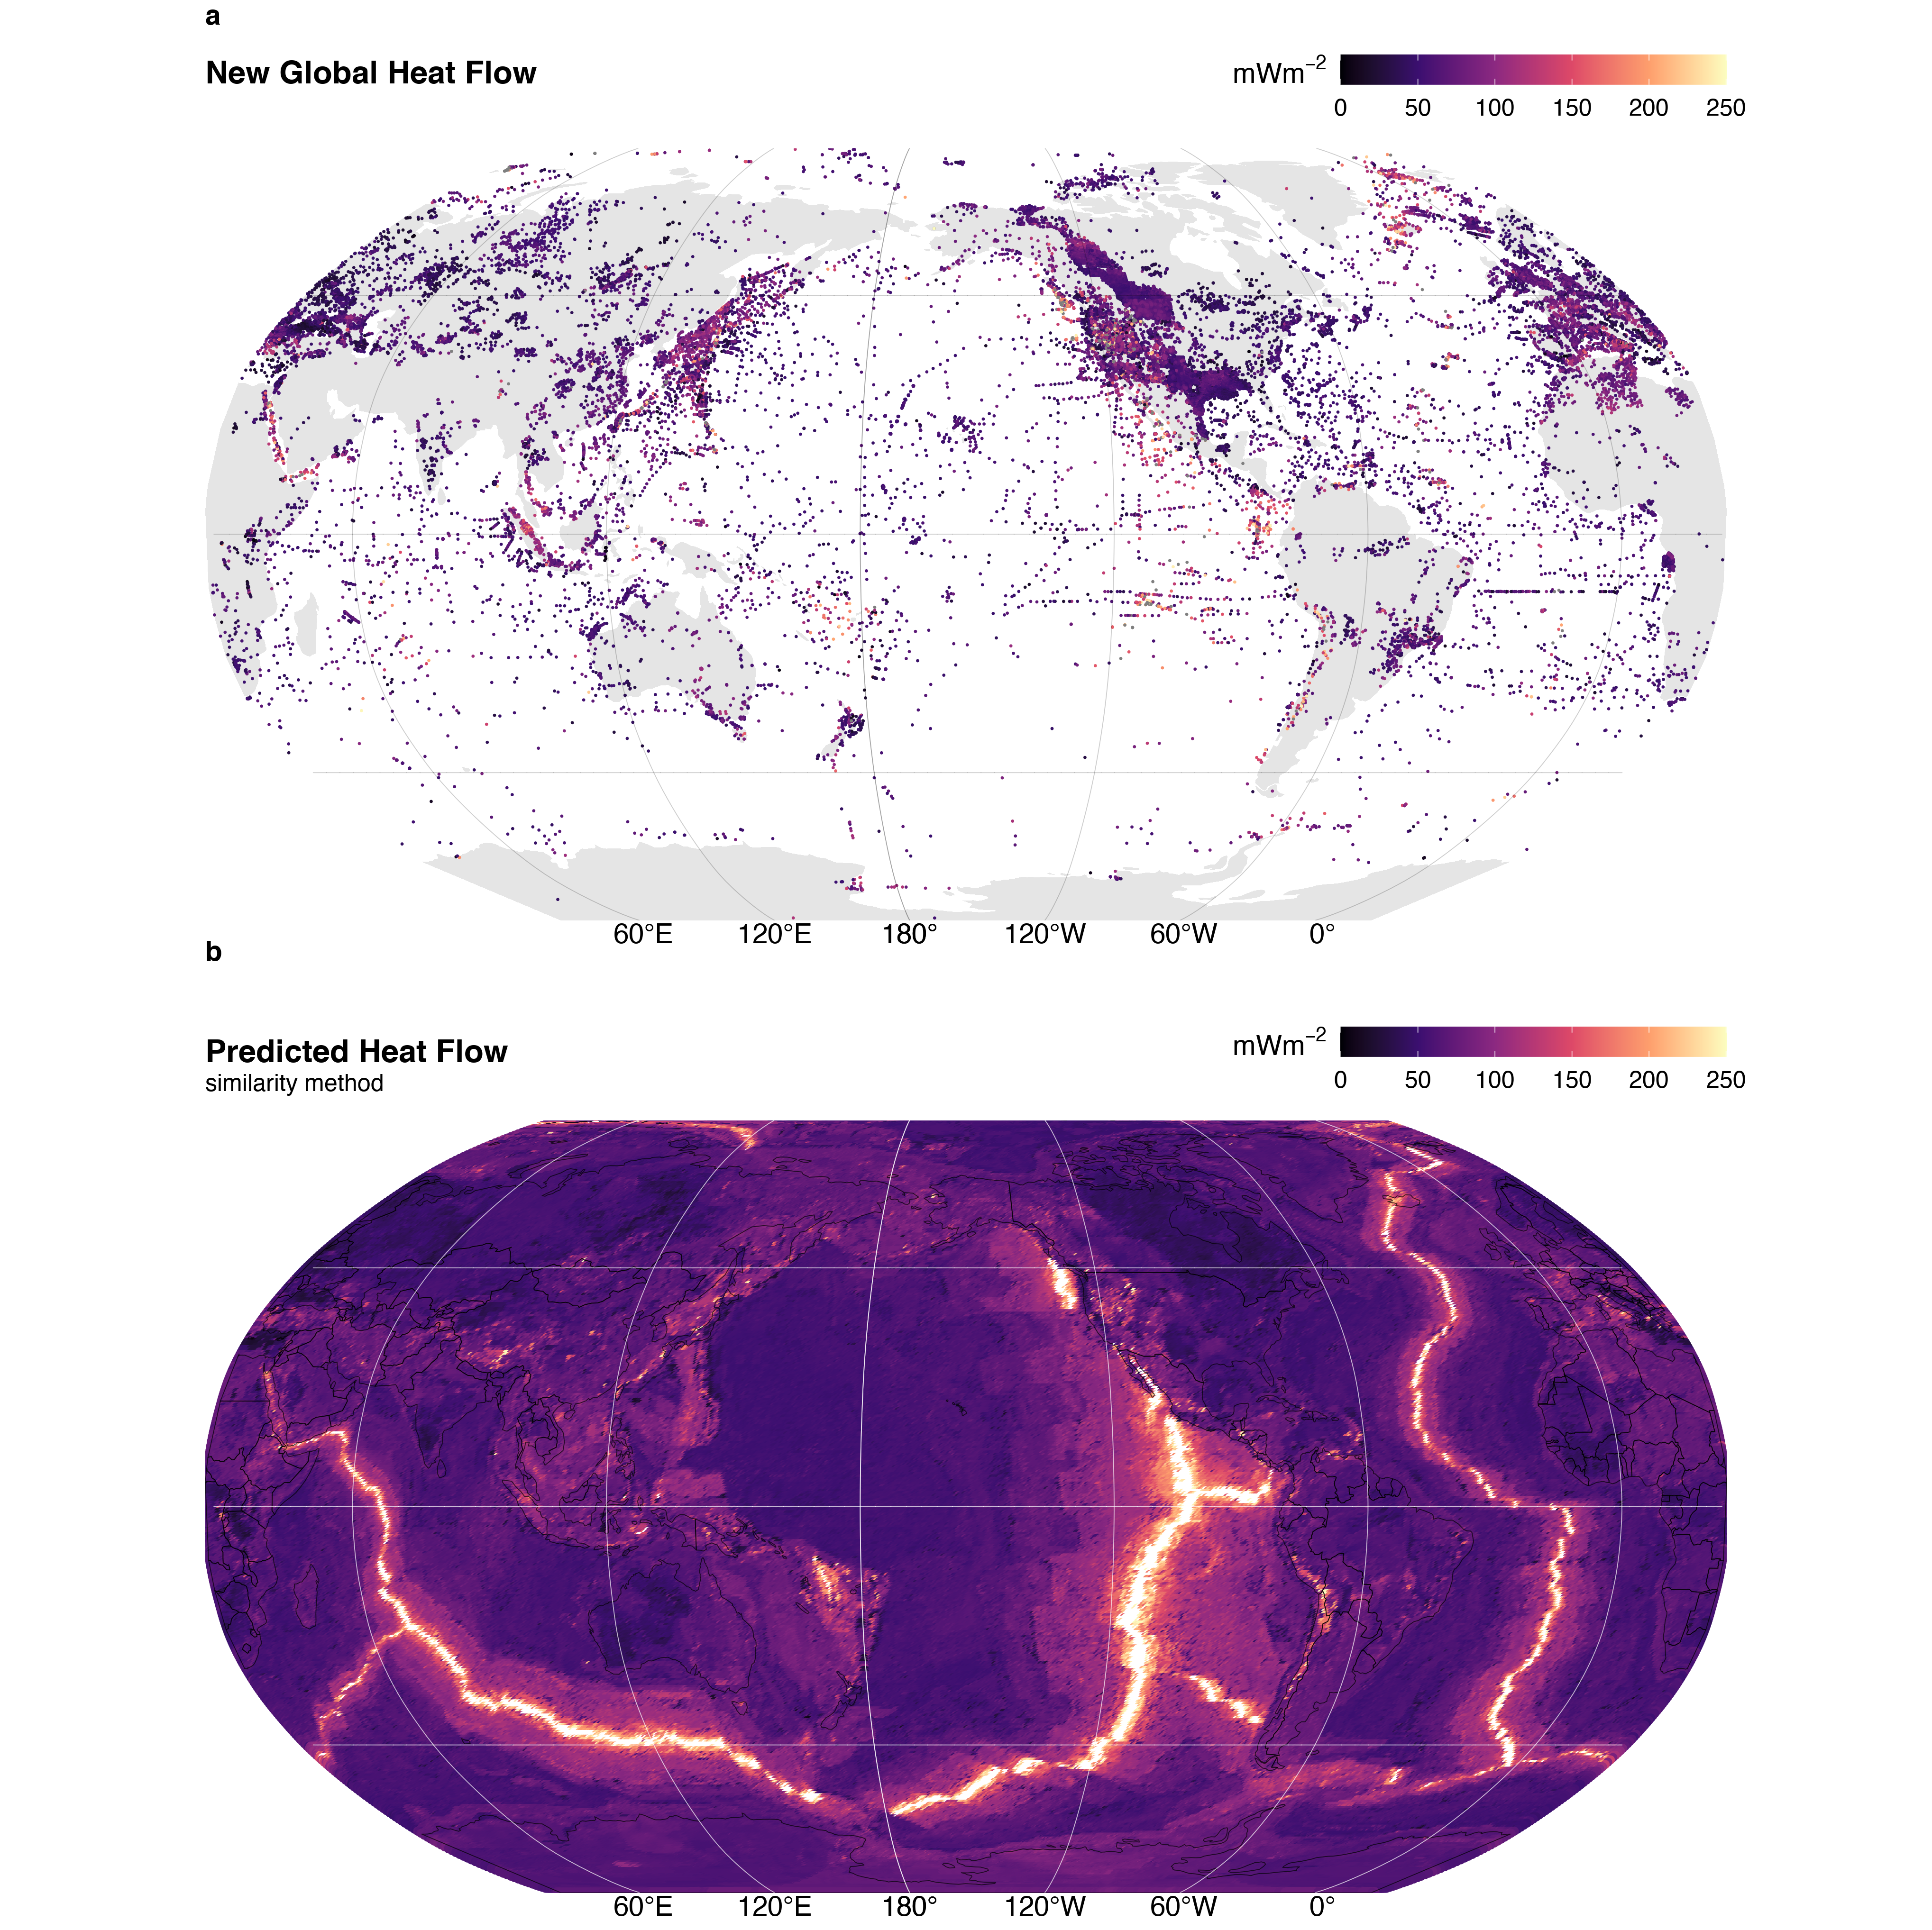

Figure 1. Global heat flow. (a) The NGHF dataset (n = 69729) and (b) interpolation by similarity method. Data from Lucazeau (2019).

In contrast, there exists some degree of spatial dependence, or continuity, in the distribution of surface heat flow. A pair of surface heat flow observations taken one meter apart will be strongly correlated. The correlation between pairs of observations will likely decrease with increasing distance between the pairs (Goovaerts, 1997). This is encapsulated in the First Law of Geography: *everything is related, but nearer things are more related* (Krige, 1951; Matheron, 1963). The spatial (dis)continuity of surface heat flow represents the areal extent of geodynamic processes and their interactions. For example, patterns of consistently low surface heat flow outline the areal extent of cratons (Figure 1) and consistent patterns of heat flow near volcanic arcs are interpreted to reflect common backarc lithospheric thermal structures and slab-mantle mechanical coupling depths in subduction zones (Furukawa, 1993; Kerswell et al., 2020; Wada & Wang, 2009).

Predicting surface heat flow by considering many nearby observations (i.e. Kriging, Krige, 1951) is advantageous because the reality spatial dependence is conserved. However, Kriging is disadvantageous because it assumes that the underlying distribution of heat flow is *stationary* (constant in space and time), which fails in geodynamically complex regions. This problem is overcome by relaxing assumptions of stationarity and applying techniques that respect the Second Law of Geography: *spatial phenomena are inherently heterogenous* (Goodchild, 2004), such as directional Kriging or Markov-Bayes techniques that include proxies as priors (Bárdossy, 1997).

In this study we attempt to answer the following questions: 1) What are the differences between global heat flow interpolations predicted by Kriging and similarity methods? 2) What are the implications of the differences according to the implicit assumptions embodied in the First and Third Laws of Geography? 3) Which method is better suited for hypothesis testing in studies sampling surface heat flow?

We first use ordinary Kriging to interpolate the New Global Heat Flow (NGHF) dataset of Lucazeau (2019). Our method is optimized using a genetic algorithm that minimizes a cost function considering both the misfit on the variogram models and interpolation results (after Li et al., 2018). We then compare our interpolation results to those of Lucazeau (2019) and consider the implications of Kriging vs. similarity methods of interpolation. We restrict our comparison to areas near subduction zone segments defined by Syracuse & Abers (2006) for two reasons: 1) to provide distributions and statistics useful to subduction zone research, and 2) to emphasize differences and idiosyncrasies in both interpolation approaches in a complex tectonic and thermal setting. We find that the fidelity and usefulness of interpolations depend on the question being asked and the choice of methodology.

# Methods

## The NGHF Dataset

The NGHF dataset was downloaded from the supplementary material of Lucazeau (2019). It contains 69729 data points, their locations in latitude/longitude, and metadata—including a data quality rank (Code 6) from A to D (with Code 6 = Z = undetermined). The reader is referred to Lucazeau (2019) for details on compilation, references, and historical perspective on the NGHF and previous compilations. We use NGFH because it is the most recent dataset available, has been carefully compiled, and is open-access.

Like Lucazeau (2019), we exclude 4790 poor quality observations (Code 6 = D) from our analysis. We further remove 350 data points without heat flow observations and two without geographic information. Multiple observations at the same location are parsed to avoid singular covariance matrices during Kriging:

$$\begin{matrix}f(X_{i}^{q},Y_{i}^{q}) & = \\ X_{i}^{q}>Y_{i}^{q} & →z_{i}=x_{i} \\ X_{i}^{q}<Y_{i}^{q} & →z_{i}=y_{i} \\ X_{i}^{q}=Y_{i}^{q} & →z_{i}=RAND(x_{i},y_{i})\end{matrix} (1)$$

where $X_{i}^{q}$ and $Y_{i}^{q}$ represent the quality of each duplicate observation pair at location $i$, $RAND$ is a random function that selects either the observation $x_{i}$ or $y_{i}$, and $z_{i}$ stores the observation selected by $f(X_{i}^{q},Y_{i}^{q})$. The final dataset used for Kriging has $n=$ 55274 observations after parsing $n=$ 32430 duplicate observation.

## Kriging

Kriging is a three-step process that involves first estimating an experimental variogram, $\hat{γ}(h)$, fitting the experimental variogram with one of many variogram models, $γ(h)$, and finally using the modelled variogram to predict random variables at unknown locations (Cressie, 2015; Krige, 1951). We use the general-purpose functions defined in the “R” package gstat (Gräler et al., 2016; Pebesma, 2004) to perform all three steps. We begin by estimating an experimental variogram as defined by Bárdossy (1997):



where $N(h)$ is the number of pairs of points, $Z(u_{i})$ and $Z(u_{j})$, separated by a lag distance, $h=|u_{i}-u_{j}|$. We evaluate $\hat{γ}(h)$ at fifteen lag distances by binning the irregular spaced data with a bin width, $δ$, equal to a proportion of the maximum lag distance, $c$, divided by the number of lags used to evaluate the variogram. The lag cutoff parameter, $c$, is optimized by genetic algorithm (discussed below). The binwidth is then $δ=\text{max}(N(h))/(15c)$, and $N(h)←N(h,δh)=\{i,j:|u_{i}-u_{j}|∈[h-δh,h+δh)\}$. In simple terms, Equation 2 represents the similarity, or dissimilarity, between pairs of observations in space. Equation 2 is adheres to the First Law of Geography and is derived from the theory of *regionalized variables* (Matheron, 1963, 2019), which formally defines a probabilistic framework for spatial interpolation of natural phenomena. It is important for the reader to understand the fundamental assumptions implicit in Equation 2 in order to understand the comparison of interpolation techniques discussed later. The basic assumptions used in our Kriging method are:

* $\hat{γ}(h)$ is directionally invariant (isotropic)
* $\hat{γ}(h)$ is evaluated in two-dimensions and neglects elevation, $Z(u)∈R^{2}$
* The first and second moments of $Z(u)$ have the following conditions over the domain $D$:

$$\begin{matrix} & E[Z(u)]=mean=constant, & ∀u∈D \\ & E[(Z(u+h)-mean)(Z(u)-mean)]=C(h), & ∀|u,u+h|∈D\end{matrix} (3)$$

The last assumption (Equation 3) is called “second-order stationarity” and is implicit in the First Law of Geography. It assumes the underlying probability distribution of the random variable, $Z(u)$, does not change in space and the covariance, $C(h)$, only depends on the distance, $h$, between two random variables. These assumptions are expected to be valid in cases where the underlying natural process is stochastic, spatially continuous, and has the property of additivity such that $\frac{1}{n}\sum_{i=1}^{n}{Z}(u_{i})$ has the same meaning as $Z(u)$ (Bárdossy, 1997).

The following are two illustrative cases where Equation 3 is likely valid:

1. The thickness of a sedimentary unit with a homogeneous concentration of radioactive elements can be approximated by $q_{s}=q_{b}+∫A dz$, where $q_{b}$ is a constant heat flux entering the bottom of the layer and $A$ is the heat production within the layer with thickness $z$ (Furlong & Chapman, 2013). If we have two samples, $Z(u_{1})=31 mW/m^{2}$ and $Z(u_{2})=30.5 mW/m^{2}$, their corresponding thicknesses would be $Z'(u_{1})=1000 m$ and $Z'(u_{2})=500 m$ for $A=0.001 mW/m^{3}$ and $q_{b}=30 mW/m^{2}$. The variable, $Z(u)$, in this case is additive because the arithmetic mean of the samples is a good approximation of the average sedimentary layer thickness, $(Z(u_{1})+Z(u_{2}))/2=750 m$.
2. The age of young oceanic lithosphere can be approximated by $q_{s}(t)=kT_{b}(πκt)^{-1/2}$, where $q_{s}(t)$ is the surface heat flow of a plate with age, $t$, $T_{b}$ is the temperature at the base of the plate, $k$ is thermal conductivity, and $κ=k/ρC_{p}$ is thermal diffusivity (Stein & Stein, 1992). For $k=3.138 W/mK$, $ρ=3330 kg/m^{3}$, $C_{p}=1171 J/kgK$, $T_{b}={1350}^{∘}C$, two samples, $Z(u_{1})=180 mW/m^{2}$ and $Z(u_{2})=190 mW/m^{2}$, would correspond to plates with ages of $Z'(u_{1})=10 Ma$, and $Z'(u_{2})=9 Ma$, respectively. Since $Z(u_{1})+Z(u_{2})/2=185 mW/m^{2}$ and $Z'(185 mW/m^{2})=9.5 Ma=Z'(u_{1})+Z'(u_{2})/2$, the variable $Z(u)$ in this case is also additive.

In contrast, Equation 3 is likely invalid in regions that transition among two or more tectonic regimes. For example, the expected heat flow $E[Z(u)]=mean$ will change when moving from a spreading center to a subduction zone. $E[Z(u)]=mean≠constant$ over the region of interest. Proceeding with Equation 3 in this case has the effect of masking the geodynamic complexity. In other words, the First Law of Geography is violated and the geodynamic complexity will be *invisible* to Kriging predictions unless heatflow observations are sufficiently dense. We will see that this has important implications when comparing our Kriging method to Lucazeau (2019)’s interpolation method, which is exactly opposite of this formalism—it only considers the similarities among physical proxies and not spatial dependence.

The second step is to fit the experimental variogram with a variogram model, $γ(h)$. In this study we fit two popular variogram models to the experimental variogram. We use models with sills, which implies the spatial dependence between pairs of points has a finite range. The spherical and exponential variogram models used in this study are defined as (Chiles & Delfiner, 2009; Cressie, 2015):

$$\begin{matrix}sph & ←γ(h)=\left\{\begin{matrix}n+s\left(\frac{3h}{2a}-\frac{1}{2}{\left(\frac{h}{a}\right)}^{3}\right), & \text{if }0≤h≤a \\ n+s, & \text{if }h>a\end{matrix}\right. \\ exp & ←γ(h)=n+s\left(1-exp\left(\frac{-h}{a}\right)\right), \text{if }h≥0\end{matrix} (4)$$

where $n$ is the nugget, $s$ is the sill, and $a$ is the effective range. The effective range, $a$, is related to the range, $r$, by $a=r$ and $a=r/3$ for spherical and exponential models, respectively (Gräler et al., 2016; Pebesma, 2004). We use the function fit.variogram in gstat to try both variogram models. The best model is selected by the minimum misfit by weighted least square (WLS, Pebesma, 2004).

We use ordinary Kriging for our interpolation step, which predicts the value of a random function, $\hat{Z}(u)$, at unknown locations as a linear combination of all known locations in the domain, $D$ (Bárdossy, 1997):

$$\hat{Z}(u)=\sum_{i=1}^{n}{λ_{i}}Z(u_{i}), ∀u∈D (5)$$

The conditions in Equation 3 set up a constrained minimization problem since one has:

$$E[Z(u)]=mean, ∀u∈D (6)$$

The linear estimator must obey

$$E[\hat{Z}(u)]=\sum_{i=1}^{n}{λ_{i}}E[Z(u_{i})]=mean (7)$$

so the weights must be

$$\sum_{i=1}^{n}{λ_{i}}=1 (8)$$

This is the first constraint, also known as the unbiased condition, which states that the sum of the weights must equal one. However, there is an infinite set of real numbers one could use for the weights, $λ_{i}$. Our goal is to find the set of weights in Equation 5 that minimizes the estimation variance. This can be solved by minimizing the covariance function, $C(h)$ from Equation 3:

$$\begin{matrix}σ^{2}(u)=Var[Z(u)-\hat{Z}(u)]=E\left[(Z(u)-\sum_{i=1}^{n}{λ_{i}}Z(u_{i}))^{2}\right] & = \\ E\left[Z(u)^{2}+\sum_{j=1}^{n}{\sum_{i=1}^{n}{λ_{j}}}λ_{i}Z(u_{j})Z(u_{i})-2\sum_{i=1}^{n}{λ_{i}}Z(u_{i})Z(u)\right] & = \\ & C(0)+\sum_{j=1}^{n}{\sum_{i=1}^{n}{λ_{j}}}λ_{i}C(u_{i}-u_{j})-2\sum_{i=1}^{n}{λ_{i}}C(u_{i}-u)\end{matrix} (9)$$

Minimizing Equation 9 with respect to the unbiased condition (Equation 8), yields the best linear unbiased estimator (BLUE, Bárdossy, 1997) for Equation 5 and together are considered the Kriging system. In our case, this is done by the function krige in gstat.

## Kriging Optimization

Achieving a useful Kriging results depends on one’s choice of many Kriging parameters ($Θ$). In this study, we investigate a set of parameters, $Θ$:

$$Θ=\{c,w,m,s,a,n,S\} (10)$$

where $c$ is the lag cutoff proportion, $w$ is the lag window, $m$ is the model type (sph or exp), $s$ is the sill, $a$ is the effective range, $n$ is the nugget, and $S$ is the maximum distance for local Kriging. Only points within $S$ from the prediction location are used for Kriging. The lag cutoff is the maximum separation distance between pairs of points used in the experimental variogram (i.e. the x-axis maximum limit) calculated as a fraction of the overall maximum separation distance for all observations, $Z(u)$, in the domain, $D$. The lag window, $w$, shifts the lags where the variogram is evaluated by removing the first $n$ lags and adding $n$ lags to the right side of the variogram. This is necessary to avoid negative ranges, $a$, when fitting experimental variograms with anomalously high variances at small lag distances.

Our goal is to find $Θ$ such that our interpolation, $f(x_{i};Θ)$, gives the most useful outcome—defined by minimizing a cost function, $C(Θ)$, that represents the error between the set of real observations, $Z(u_{i})$ and predictions, $\hat{Z}(u)$. We define a cost function that simultaneously considers the misfit between the experimental and modelled variogram and between the Kriging predictions and observed heat flow (after Li et al., 2018):

$$C(Θ)=(1-w)C_{F}(Θ)+wC_{I}(Θ) (11)$$

where $C_{F}(Θ)$ is the root mean square error (RMSE) of the modelled variogram fit calculated by WLS, and $C_{I}(Θ)$ is the RMSE of the Kriging result calculated by cross-validation. The weight, $w$, is set to 0.5 in our study, which balances the effects of $C_{F}(Θ)$ and $C_{I}(Θ)$ on the cost function. The final expression to minimize becomes:

$$\begin{matrix}C(Θ)=\frac{1-w}{σ_{E}} & \sqrt{\frac{1}{N(h)}\sum_{k=1}^{N}{w}(h_{k})[\hat{γ}(h_{k})-γ(h_{k};Θ)]^{2}} + \\ \frac{w}{σ_{S}} & \sqrt{\frac{1}{M}\sum_{i=1}^{M}{[}Z(u_{i})-\hat{Z}(u_{i};Θ)]^{2}}\end{matrix} (12)$$

where N(h) is the number of pairs of points used to calculate the experimental variogram, $\hat{γ}(h_{k})$, $σ_{E}$ is the standard deviation of the experimental variogram, $\hat{γ}(h)$, $w(h_{k})$ is the weight in WLS and defines the importance of the $kth$ lag in the error estimate. We use $w(h_{k})=N_{k}/h_{k}^{2}$. $Z(u_{i})$ and $\hat{Z}(u_{i};Θ)$ are the measured and predicted values, respectively, $σ_{s}$ is the standard deviation of the predicted values, $\hat{Z}(u_{i})$, and M is the number of measurements in $Z(u_{i})$. For $C_{I}(Θ)$ we use ten-fold cross-validation, which splits the dataset, $|Z(u_{i}), ∀u_{i}∈D|$ into ten equal intervals and tests one interval against the remaining nine. This process is then repeated over all intervals so that the whole dataset has been cross-validated.

Minimization of $C(Θ)$ is achieved by a genetic algorithm that simulates biologic natural selection by differential success (Goldberg, 1989). Our procedure is as follows:

1. Initiate fifty *chromosomes*, $ξ$, with random starting parameters defined within the search domain (Table 1)
2. Evaluate the fitness of each individual chromosome as $-C(Θ)$ for the entire population
3. Allow the population to exchange genetic information by sequentially performing genetic operations:
   1. Selection: the top 5% fittest chromosomes survive each generation
   2. Crossover: pairs of chromosomes have an 80% chance of exchanging genetic information
   3. Mutation: there is a 10% chance for random genetic mutations
4. Evaluate the fitness of the new population
5. If the termination criterion is met, do step (6), otherwise continue to evolve by repeating steps (3) and (4)
6. Decode the best chromosome and build the optimal variogram

We use the general-purpose functions in the “R” package GA (Scrucca, 2013, 2016) to perform each step in the above procedure.

Table 1: Parameters and ranges used in the optimization algorithm

|  |  |  |
| --- | --- | --- |
| Parameter | Search Domain | Units |
| Lag Cutoff (c) | [$1/3$, $1/15$] | NA |
| Lag Window (w) | [1, 5] | NA |
| Model (m) | [Spherical, Exponential] | NA |
| Sill (s) | [1, $1000\sqrt{2}$] | $$mWm^{-2}$$ |
| Effective Range (a) | [1, 1000] | km |
| Nugget (n) | [1, $1000\sqrt{2}$] | $$mWm^{-2}$$ |
| Local Search (S) | [1, 1000] | km |

## Map Projection and Interpolation Grid

We interpolate onto the same 0.5 $​^{∘}$ C x 0.5 $​^{∘}$ C grid as Lucazeau (2019) so a direct difference could be calculated between our interpolation methods and Lucazeau (2019)’s. The NGHF and grid with predicted heat flow from Lucazeau (2019) were transformed into a Pacific-centered Robinson coordinate reference system (CRS) defined using the proj string (PROJ contributors, 2021):

+proj=robin +lon_0=-155 +lon_wrap=-155 +x_0=0 +y_0=0  
+ellps=WGS84 +datum=WGS84 +units=m +no_defs

All geographic operations, including Kriging and taking the difference with Lucazeau (2019)’s heat flow predictions, are performed in the above CRS using the general-purpose functions in the “R” package sf (Pebesma, 2018). We define the Kriging domain near individual arc segments in two steps: 1) 1000 $km$ buffers are drawn around the arc segments as defined by Syracuse & Abers (2006). 2) The bounding box of the 1000 $km$ buffer is expanded by 10% on all sides (Figure 2). We use Lucazeau (2019)’s grid for Kriging predictions so differences can be taken point-by-point at the exact same locations.

We provide the complete NGHF dataset (Lucazeau, 2019), filtered and parsed NGHF dataset, heat flow interpolations (from Lucazeau, 2019, and this study), and our code as supplementary information to support FAIR data policy (Wilkinson et al., 2016). These materials can also be retrieved from the official repository at <https://doi.org/10.17605/OSF.IO/CA6ZU>.

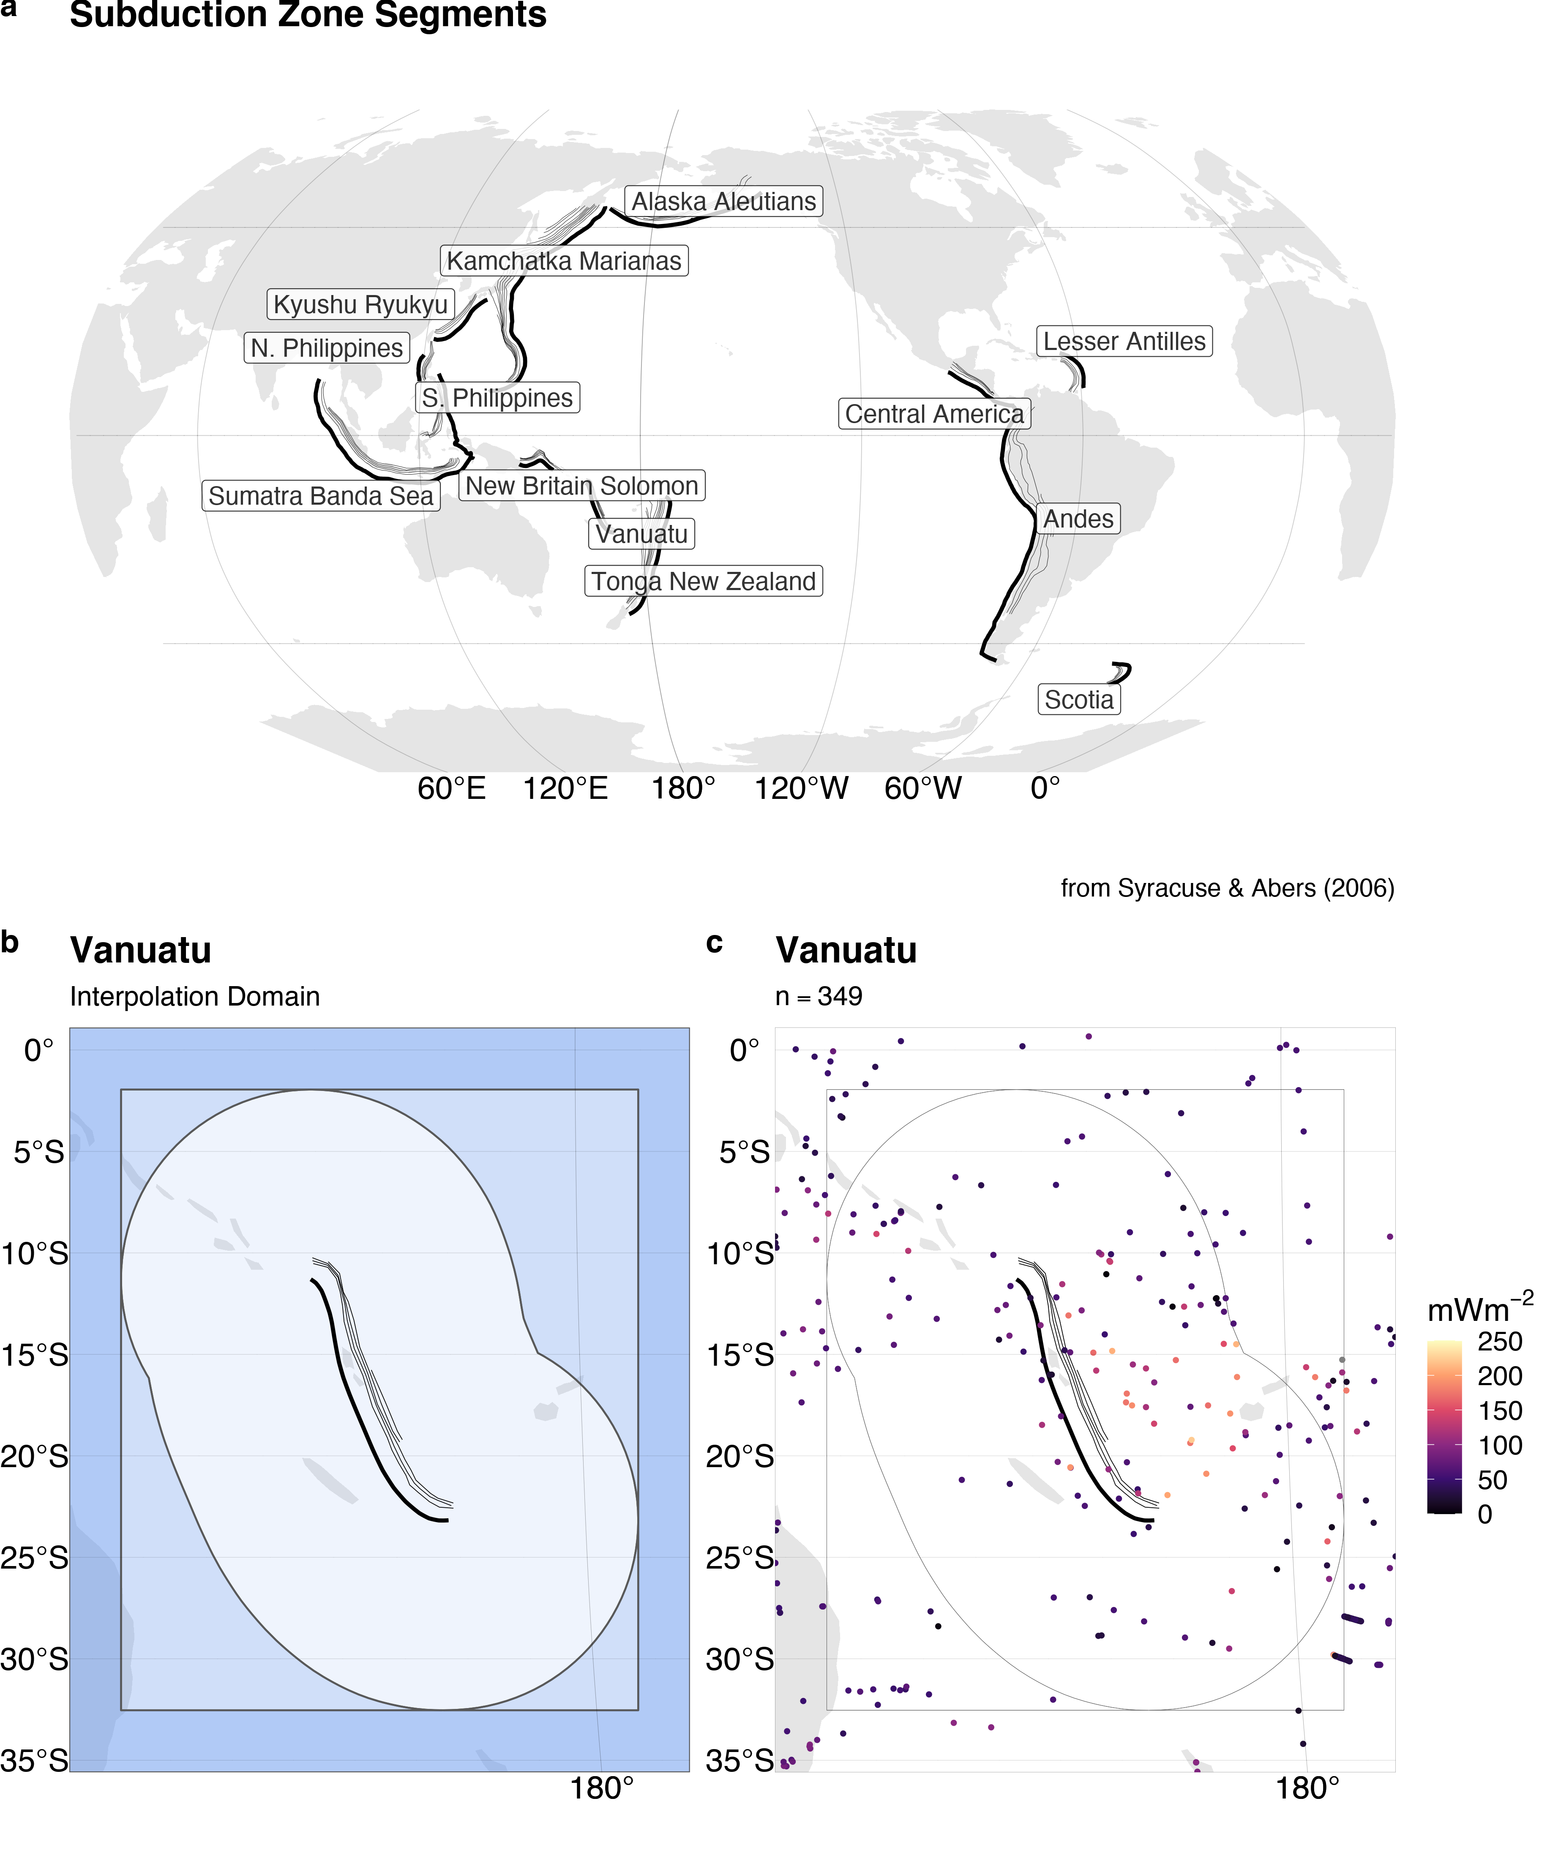

Figure 2. Subduction zone segments and interpolation domain. (a) Heat flow is interpolated around thirteen subduction zone segments by (b) drawing a 1000km buffer (lightest blue) around each segment and expanding the buffer’s bounding box (medium blue) by 10% on all sides (darkest blue). (c) The NGHF dataset is cropped within the largest rectangle. Data from Syracuse & Abers (2006) and Lucazeau (2019).

# Results

## Heat Flow Near Subduction Zone Segments

Summary statistics for surface heat flow observations by subduction zone segment are given in Table 2 and Figure 3. Surface heat flow is median-centered around 45-70 $mWm^{-2}$ and narrowly distributed (excluding outliers) with inter-quartile ranges (IQR) from 12 to 50 $mWm^{-2}$ for most subduction zone segments. Alaska Aleutians is the exception with a higher median of 184 $mWm^{-2}$ and broader range (IQR = $250 mW^{-2}$). The whole distributions (including outliers) for all segments are strongly right-skewed with maximum heat flow values of several thousand of $mWm^{-2}$ or more. Heat flow values above 250 $mWm^{-2}$ are considered geothermal areas by Lucazeau (2019), which we adopt as a relevant empirical limit for anomalously high heat flow.

Table 2: Heat flow ($mWm^{-2}$) observations

|  |  |  |  |  |  |  |  |
| --- | --- | --- | --- | --- | --- | --- | --- |
| Segment | n | Min | Max | Median | IQR | Mean | Sigma |
| Alaska Aleutians | 2791 | 4 | 7765 | 184 | 206 | 233 | 345 |
| Andes | 5226 | 7 | 911 | 45 | 50 | 87 | 89 |
| Central America | 5033 | 8 | 911 | 45 | 48 | 88 | 91 |
| Kamchatka Marianas | 3958 | 1 | 25200 | 71 | 48 | 118 | 582 |
| Kyushu Ryukyu | 3247 | 1 | 25200 | 72 | 44 | 126 | 642 |
| Lesser Antilles | 3535 | 13 | 1150 | 41 | 13 | 52 | 50 |
| N. Philippines | 1002 | 3 | 25200 | 72 | 35 | 195 | 1127 |
| New Britain Solomon | 180 | 3 | 174 | 64 | 42 | 69 | 30 |
| S. Philippines | 1444 | 1 | 25200 | 71 | 43 | 158 | 938 |
| Scotia | 72 | 13 | 145 | 76 | 23 | 74 | 28 |
| Sumatra Banda Sea | 3039 | 1 | 1350 | 65 | 47 | 76 | 67 |
| Tonga New Zealand | 507 | 2 | 416 | 54 | 40 | 64 | 45 |
| Vanuatu | 349 | 2 | 283 | 54 | 40 | 64 | 44 |

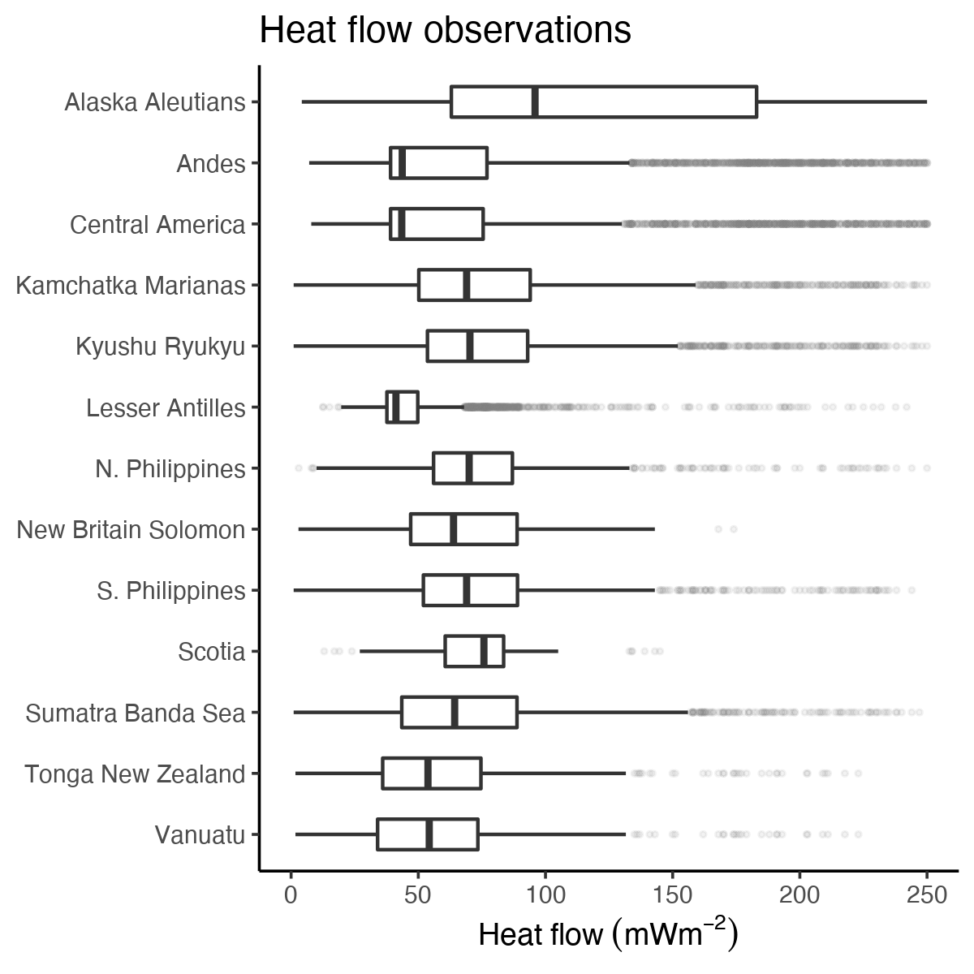

Figure 3. Distribution of heat flow observations. Heat flow near most segments is centered around $50 mWm^{-2}$ and highly skewed right (shadowy dot outliers). The skeweness likely represents sampling near geothermal systems, volcanic arcs, or spreading centers. Data from Lucazeau (2019).

## Variogram Models

The optimal variogram models and associated errors $C_{F}(Θ)$ and $C_{I}(Θ)$ are given in Table 3. Almost twice as many experimental variograms are fit with spherical models (8) compared to exponential models (5). Variogram model sills vary substantially among the subduction zone segments between 9 and 1538 $mWm^{-2}$. Variogram model ranges also vary substantially among segments from 4 to 1676 $km$.

No apparent correlation exists between variogram model range and subduction zone segment length, number of heat flow observations, nor domain area (Figure 4). Most subduction zone segments show spatial dependence of a few hundred kilometers or less, irrespective of the number of observations or segment size. The exceptions are Kyushu Ryukyu (range = 1774 $km$) and Vanuatu (range = 573 $km$), whose model variogram ranges are, perhaps, anomalously high.

Table 3: Optimal varigram models

|  |  |  |  |
| --- | --- | --- | --- |
| Segment | Model | Sill $[mWm^{-2}]$ | Range $[km]$ |
| Alaska Aleutians | Sph | 285 | 221 |
| Andes | Sph | 87 | 346 |
| Central America | Sph | 86 | 343 |
| Kamchatka Marianas | Exp | 612 | 271 |
| Kyushu Ryukyu | Sph | 813 | 1774 |
| Lesser Antilles | Exp | 38 | 104 |
| N Philippines | Sph | 1198 | 238 |
| New Britain Solomon | Exp | 29 | 89 |
| S Philippines | Sph | 1026 | 414 |
| Scotia | Exp | 9 | 4 |
| Sumatra Banda Sea | Sph | 67 | 133 |
| Tonga New Zealand | Sph | 47 | 131 |
| Vanuatu | Sph | 48 | 573 |

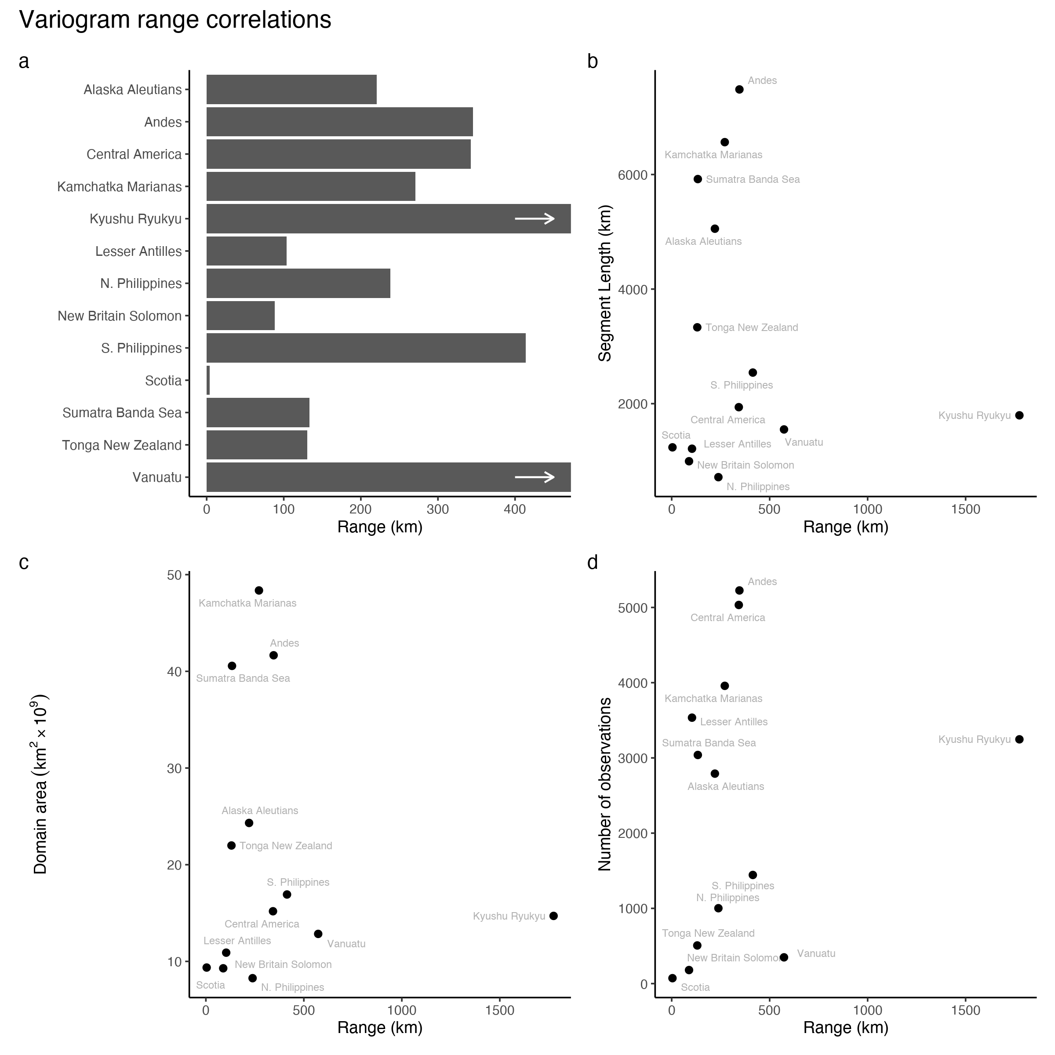

Figure 4. Summary of variogram model ranges and correlations with other features. (a) Variogram model ranges are variable, but generally below 400 km. Variogram model ranges show no correlation with segment length (b), number of heat flow observations (c), nor domain area (d). The spatial dependenc of heat flow is apparently independent of these parameters.

## Interpolation Comparison

Summary statistics for the interpolation differences are given in Table 4 and Figure 5. Note that the difference is taken at the exact same locations for every prediction. Differences between the similarity method and Kriging are small for most segments with the exception of Central America, which shows a broader distribution of differences than the other segments. The median differences range from -9 to 7 $mWm^{-2}$ with inter quartile ranges from 15 to 62 $mWm^{-2}$. Similar to the distribution of heat flow in these areas, the minimum and maximum difference in predicted heat flow are extreme and represent the failure of one method to predict extreme outliers of the other.

Table 4: Predicted heat flow ($mWm^{-2}$) differences

|  |  |  |  |  |  |  |
| --- | --- | --- | --- | --- | --- | --- |
| Segment | Min | Max | Median | IQR | Mean | Sigma |
| Alaska Aleutians | -550 | 2659 | -2 | 20 | 3 | 71 |
| Andes | -241 | 2336 | 2 | 35 | 12 | 72 |
| Central America | -242 | 2731 | 8 | 63 | 43 | 147 |
| Kamchatka Marianas | -2434 | 297 | 4 | 15 | 4 | 39 |
| Kyushu Ryukyu | -2435 | 136 | 6 | 24 | 2 | 74 |
| Lesser Antilles | -148 | 566 | 0 | 16 | 5 | 31 |
| N Philippines | -2131 | 283 | 2 | 24 | -1 | 67 |
| New Britain Solomon | -81 | 236 | 2 | 22 | 5 | 20 |
| S Philippines | -273 | 369 | 5 | 26 | 7 | 30 |
| Scotia | -62 | 1001 | -4 | 24 | 5 | 33 |
| Sumatra Banda Sea | -312 | 386 | 0 | 20 | 2 | 20 |
| Tonga New Zealand | -113 | 1695 | -9 | 23 | -2 | 30 |
| Vanuatu | -166 | 1657 | 7 | 27 | 8 | 40 |

Prediction differences are either approximately normally distributed, or skewed right. Right skew and a tendency of medians to deviate positively from zero both reflect a systematic overprediction of heat flow by the similarity method compared to Kriging (Figure 5). However, Alaska Aleutians, Scotia, and Tonga New Zealand have negative median differences. While there is a tendency for the similarity method to overpredict heat flow compared to Kriging, it is not true in every case.

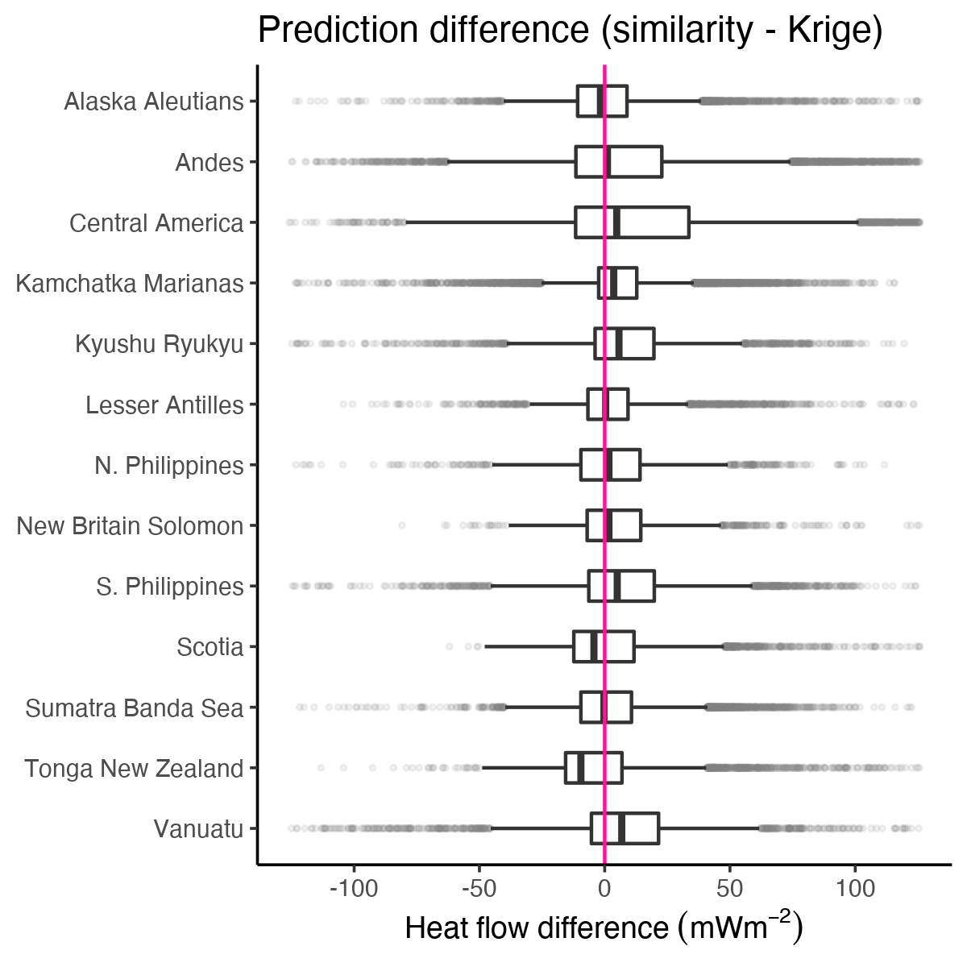

Figure 5. Point-by-point differences of predicted heat flow between similarity and Kriging interpolations. The differences for most subduction zone segments are median-centered at or near-zero with IQRs from 16 to 62. Outliers (shadowy dots) extend to extreme positive and negative differences.

Notable sources of prediction differences include 1) tectonic features predicted by similarity that are absent from Kriging or 2) general discordance between the spatial continuity of heat flow observations and similarity predictions. For example, high heat flow representing Galápagos triple junction is predicted by similarity to the SW of the Central America segment (Figure 6a). However, none of the triple junction arms, nor the Galápagos hot spot, are well defined in the Kriged prediction (Figure 6b). The interpolation comparison for Central America highlights two distinct regions—bright differences along the arms of the triple junction and muted agreement to the E and NE of the Cocos Plate (Figure 6c). Note the moderate differences within the Cocos Plate in Figure 6a where similarity predicts high heat flow by proximity to the nearby spreading centers, but heat flow in the region is, in fact, relatively low (compare Figure 6a, b, c). Similar discordance between high similarity predictions and low heat flow observations are observed in many subduction zone segments, especially near spreading centers predicted by similarity (e.g. Figure 12; see Appendix).

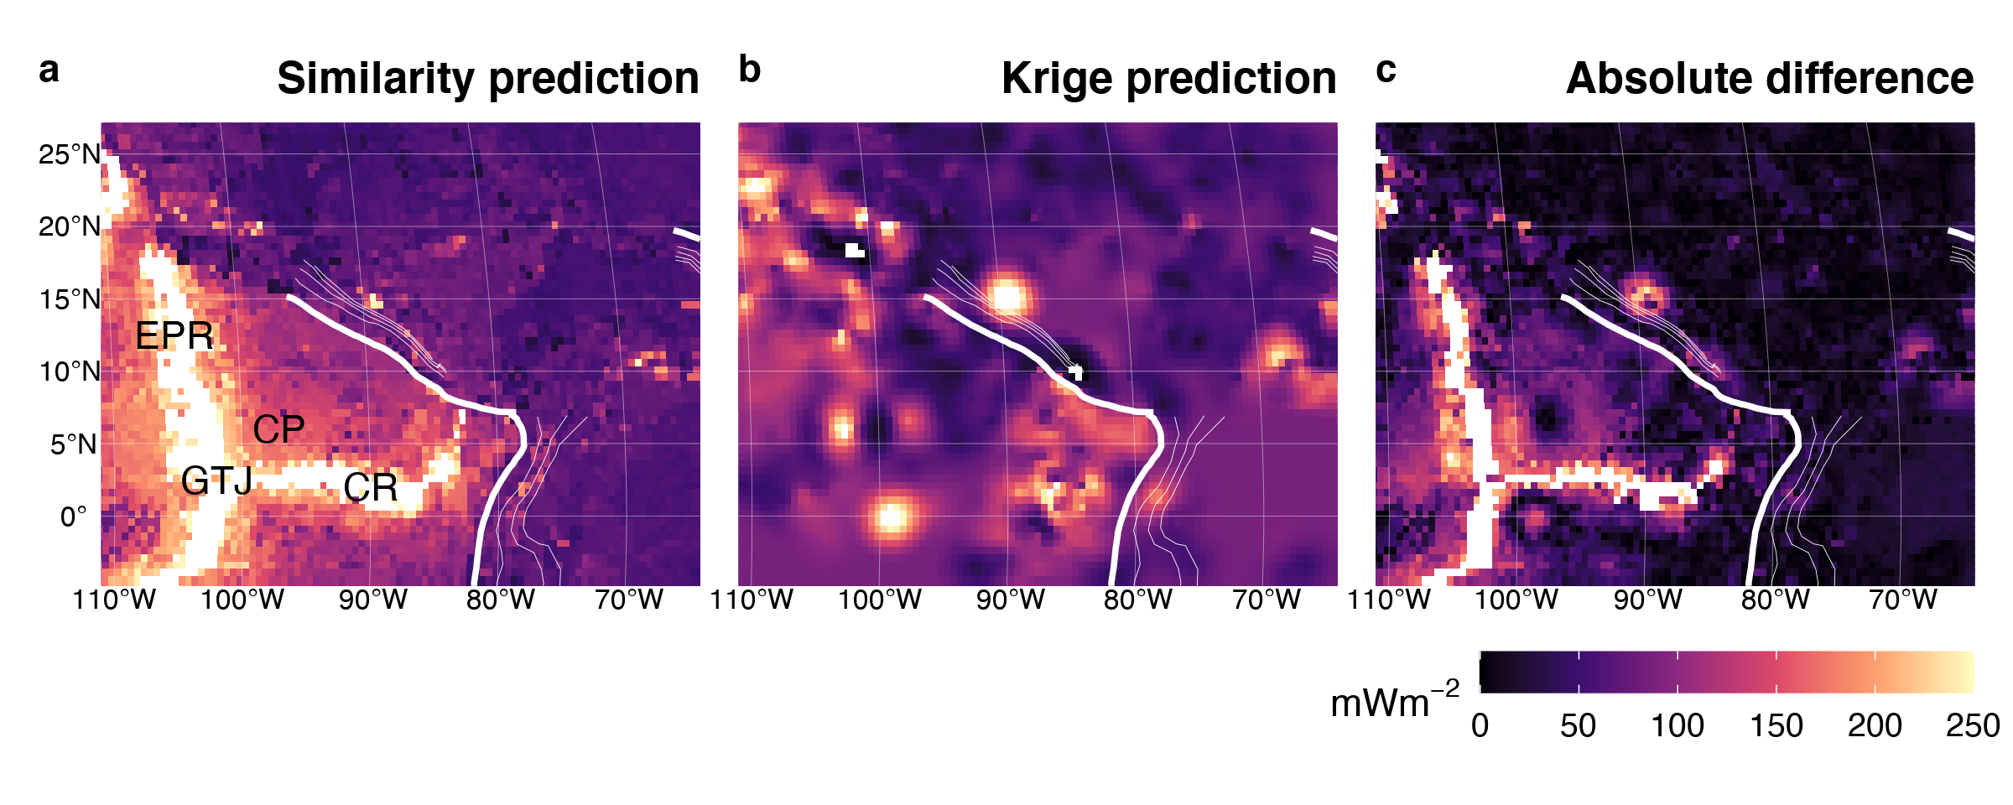

Figure 6. Similarity vs. Kriging predictions for Central America. The Galápagos triple junction (GTJ), East Pacific Rise (EPR), and Cocos Ridge (CR) are predicted by similarity (a), but not by Kriging (b). Note the moderate difference between predictions within the Cocos Plate (CP) where similarity predicts high heat flow but observations are low (c). Bold and thin white lines represent the subduction zone segment boundary and plate depth, respectively, as defined by Syracuse & Abers (2006). Heat flow data and similarity prediction from Lucazeau (2019).

On the other side of the Caribbean Plate, near the Lesser Antilles segment, similarity and Kriging predictions show good agreement. The Mid-Atlantic Ridge to the E appears in both predictions (Figure 7a, b). The spreading center is better defined with Kriging in this case, as compared to the Galápagos triple junction, because the observational density and spatial coverage near the Lesser Antilles segment are sufficiently high and continuous near the Mid-Atlantic Ridge (seeAppendix). However, the comparison still highlight spreading centers as similarity tends to predict higher heat flow than observations.

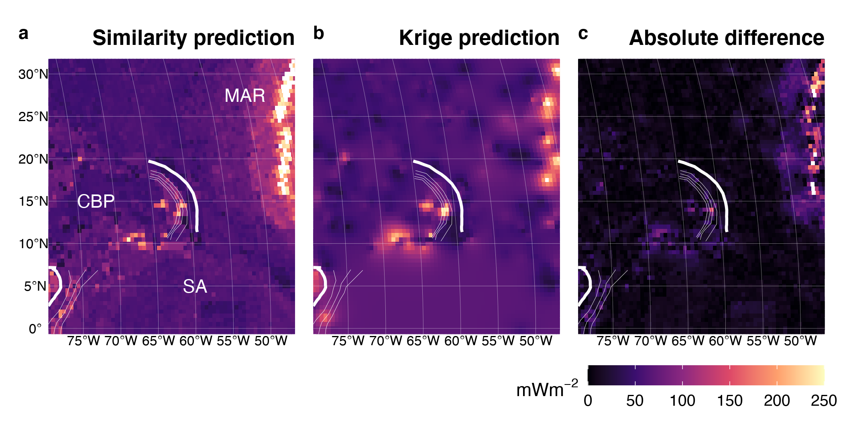

Figure 7. Similarity vs. Kriging predictions for the Lesser Antilles. The Mid-Atlantic Ridge (MAR) predicted by similarity (a) is also defined by Kriging (b) because of adequate observational density and spatial coverage near the spreading center. Good agreement between similarity and Kriging exist for the entire domain (c). CBP = Caribbean Plate, SA = South America. Bold and thin white lines represent the subduction zone segment boundary and plate depth, respectively, as defined by Syracuse & Abers (2006). Heat flow data and similarity prediction from Lucazeau (2019).

Another example of good agreement between similarity and Kriging are interpolations near the Sumatra Banda Sea segment (Figure 8; Figure 20). Note the textural and structural complexity predicted by similarity (Figure 8a) compared to the smooth featureless Kriging predictions (Figure 8b). Despite the textural and structural differences, the difference between similarity and Kriging within the Sunda Plate, Australian Plate, and W Philippine Sea Plate is small (Figure 8c).

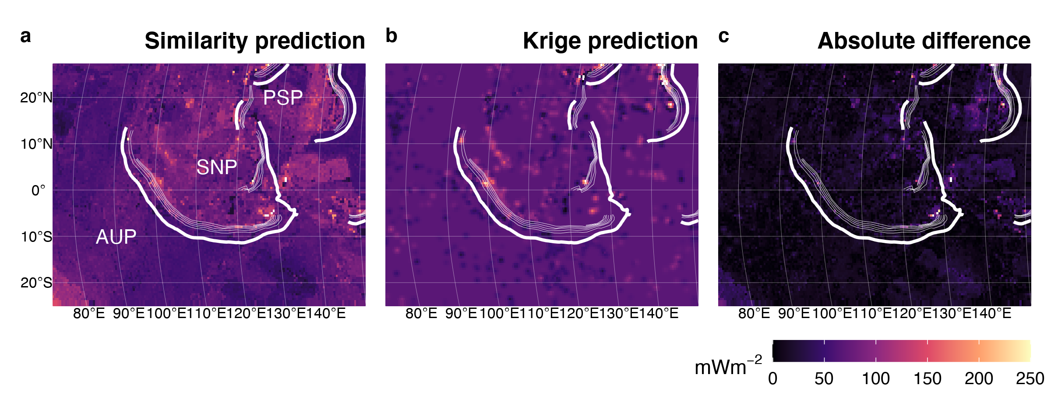

Figure 8. Similarity vs. Kriging predictions for Sumatra Banda Sea. Similarity predictions are texutrally and structurally complex (a), while Kriging is smooth and featureless (b). Despite the textural and structural difference, the interpolations are similar, especially within the Sunda Plate (SNP), Australian Plate (AUP) and W Philippine Sea Plate (PSP). Bold and thin white lines represent the subduction zone segment boundary and plate depth, respectively, as defined by Syracuse & Abers (2006). Heat flow data and similarity prediction from Lucazeau (2019).

Heat flow predictions near the Scotia segment illustrate a case where heat flow observations are incredibly sparse. Similarity predicts high heat flow from the East Scotia Ridge (ESR) and the WSW-ENE trending transform boundary separating the Scotia and Sandwich Plates from the Antartic Plate (Figure 9a). Figure 9b appears featureless because very few heat flow observations (n = 72) define a flat experimental variogram for all lag distances greater than four kilometers (no spatial dependence beyond 4 km, Table 3; Figure 21). Kriging predicts the expected (mean) heat flow value for the entire domain (Figure 9b), in this case, according to Equation 5. Interestingly, the expected heat flow is a fine predictor for most of the ocean basin, except near the spreading center and transform fault (Figure 9c). The New Britain Solomon segment shows a similar comparison (Figure 18) with good agreement between similarity and Kriging despite very few heat flow observations, little spatial dependence (small variogram range), and a featureless Kriged interpolation.

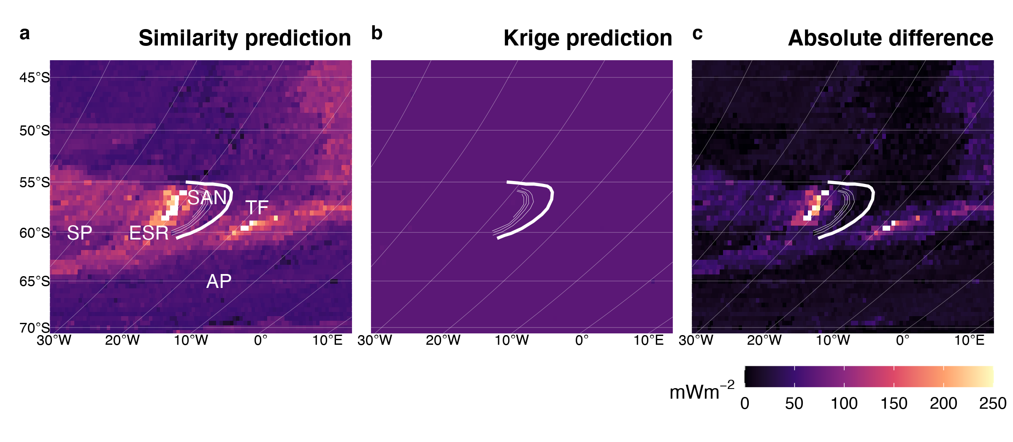

Figure 9. Similarity vs. Kriging predictions for Scotia. (a) Similarity predicts high heat flow for two tectonic features, the East Scotia Ridge (ESR) and a transform fault (TF) separating the Scotia and Sandwich Plates (SP, SAN) from the Antartic Plate (AP). Kriging (b) is featureless because of incredibly sparse data. Despite few heat flow observations. Kriging predictions are only significantly different than similarity predictions near the ESR and transform fault (c). Bold and thin white lines represent the subduction zone segment boundary and plate depth, respectively, as defined by Syracuse & Abers (2006). Heat flow data and similarity prediction from Lucazeau (2019).

While similarity tends to define tectonic features and Kriging tends to smooth out tectonic features, we find the opposite pattern within the tectonically-complex region near Vanuatu. Similarity predicts the N-S trending spreading center separating the New Hebrides plate from the Balmoral Reef and Conway Reef microplates (Figure 10a). However, heat flow observations are sufficiently dense and continuous to partially resolve the short ridge segments and transform faults outlining the microplates between Vanuatu and the Tonga New Zealand segments by Kriging (Figure 10b). The differences (Figure 10c) are difficult to interpret because of the somewhat random discordance between interpolation methods.



Figure 10. Similarity vs. Kriging predictions for Vanuatu. (a) Similarity resolved the spreading center separating the New Hebrides Plate (NHP) from the Balmoral Reef (BR) and Conway Reef (CR) microplates. Sufficient heat flow observations allow Kriging to resolve additional ridge segments and transform faults outlining BR and CR (b). The difference between similarity and Kriging (c) is discordant and difficult to interpret. Bold and thin white lines represent the subduction zone segment boundary and plate depth, respectively, as defined by Syracuse & Abers (2006). Heat flow data and similarity prediction from Lucazeau (2019).

# Discussion

## Kriging Optimization

Variogram model ranges characterize the maximum separation distance at which pairs of points are spatially dependent (Matheron, 1963). Therefore, the range is the most important parameter to evaluate when considering spatial continuity of heat flow.

## The First and Third Laws of Geography

The Third Law of Geography states that *two points with similar geographic configurations should have similar values*. In the context of heat flow near subduction systems and associated spreading centers, the Third Law produces interpolations that highlight discrete tectonic features (spreading centers and large fault systems) with complex regional texture. At first glance the textural complexity may be misconstrued as realistic interpolations, but is merely an artifact of the similarity method. The texture predicted by similarity is artificial insofar as it does not represent spatial changes in surface heat flow. Rather each prediction location represents an independent assignment of heat flow by association to all other locations with similar geographic configurations (Goutorbe et al., 2011; Lucazeau, 2019; Zhu et al., 2018). The extent to which similarity predictions represent real changes of heat flow in space is entirely dependent on the reliability of the Third Law, the quality of the physical proxies, and the selected combination of proxies used for interpolation.

We note a few inconsistencies with Lucazeau (2019)’s similarity predictions in the domains considered in this study. First, Lucazeau (2019)’s predictions systematically overpredict heat flow near spreading centers, justifying an adjustment to their algorithm. Second, known tectonic features within the tectonically-complex region near Vanuatu may be better resolved by Kriging than Lucazeau (2019)’s predictions. It is important to note, however, that Vanuatu is the only case where Kriging resolves tectonic features that similarity does not; the trend is otherwise opposite. Moreover, the inconsistencies near Vanuatu do not imply algorithmic issues and can likely be resolved by similarity using a finer-scale grid.

The more important inconsistencies are general discordance between similarity predictions and observations. Disagreements with observations imply failures of the Third Law, which are not easily correctable algorithmically. Cross-validation statistics given by Lucazeau (2019) demonstrate good agreement with observations in general. The cross-validation error may be sufficiently small for calculating global heat flux and probing other relevant questions on the global scale. However, testing hypotheses which require sampling heat flow on the subduction zone segment scale should carefully consider where predictions and observations differ, regardless of the interpolation method (discussed further below).

Unlike the Third Law, the First Law of Geography by definition does not allow discordance between predictions and observations. This fact can be colloquially stated as *everything is related, but nearer things are more related (and points at the exact same location are perfectly related)*. More formally, the covariance of two points at the same location must be zero. Comparing the First and Third Laws reveals further asymmetry in the sources of errors. Sources of interpolation error include: 1) quality of heat flow observations (First & Third Law), 2) variance of predictions at unknown locations (First & Third Law), 3) residuals of predictions at known locations (Third Law), 4) Kriging weights (variogram model; First Law), 5) variances of physical proxies (Third Law), 6) combinations of physical proxies (Third Law), 7) similarity weights (similarity model; Third Law). Interpolation uncertainty is easier to conceptualize and quantify for First Law interpolations than Third Law interpolations.

Arguments in favor of First or Third Law interpolations, however, are not easily generalized. Third Law interpolations are justified in cases with inadequate heat flow observations (e.g. Scotia and New Britain Solomon). First Law interpolations are arguably more favorable in all cases with adequate heat flow observations because 1) enough observations will resolve important features, 2) spatial dependency is respected, and 3) there are fewer sources of uncertainty. However, it is difficult to know what “adequate” observational density and spatial coverage are *a priori*. In any case, it may not be feasible to achieve adequate observational density and spatial coverage due to time and budget constraints. Therefore, hypotheses and sampling strategies should be constructed with careful consideration of whether First or Third Law interpolations are more appropriate on a case-by-case basis.

## Heat Flow Sampling and Hypothesis Testing

Testing hypotheses relating to subduction dynamics and seismicity require sampling of heat flow. Sampling in previous work commonly uses a three-part strategy: 1) draw a cross-section line perpendicular to the trench, 2) draw a rectangle with arbitrary width bisected by the section line, 3) gather all heat flow observations within the rectangle and project them onto the section line. This sampling strategy is simple and most effective for section lines with nearby, equally spaced, high-density observations (almost never the case). The method increasingly violates the First Law as the size of the sampling rectangle increases, including more disparate points. This strategy must also be repeated many times along strike to fully characterize the spatial distribution of heat flow near subduction zone segments. Repeated sampling along strike has not been done in previous studies.

The Third Law has been used successfully in calculating global surface heat flux [] and testing lithospheric cooling models [].

# Conclusions

# Appendix

## Heat flow observations and predictions

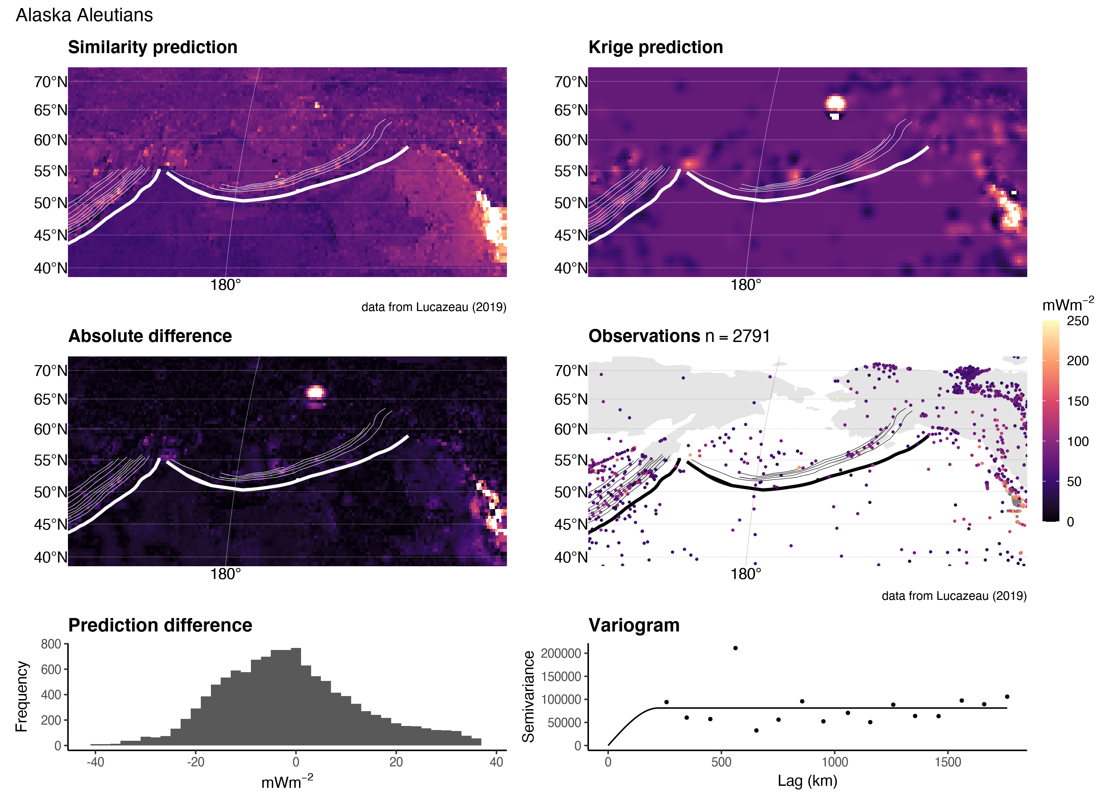

Figure 11. Similarity vs. Kriging predictions for Alaska Aleutians.

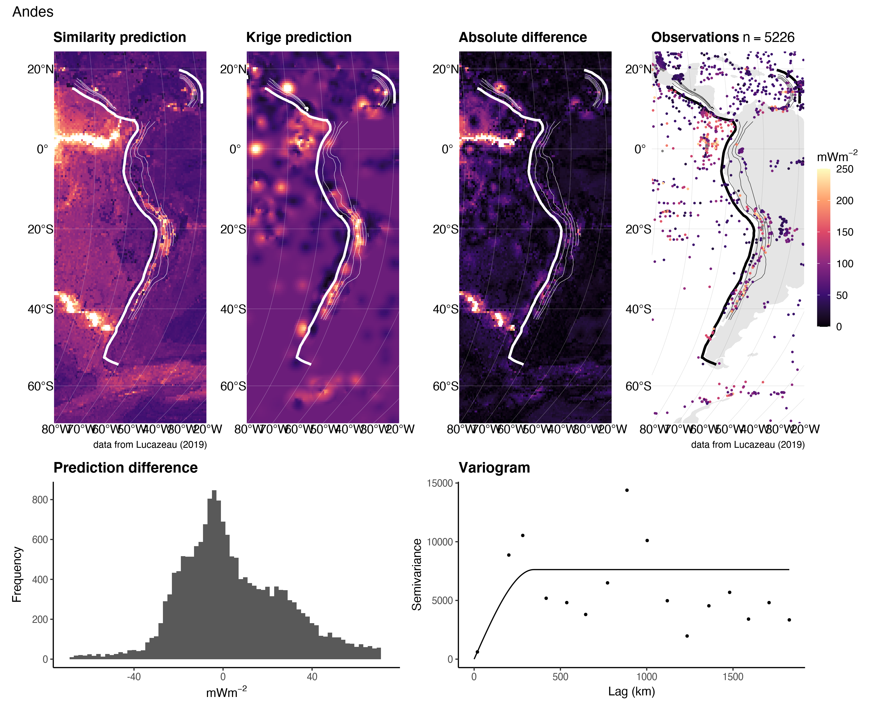

Figure 12. Similarity vs. Kriging predictions for the Andes.

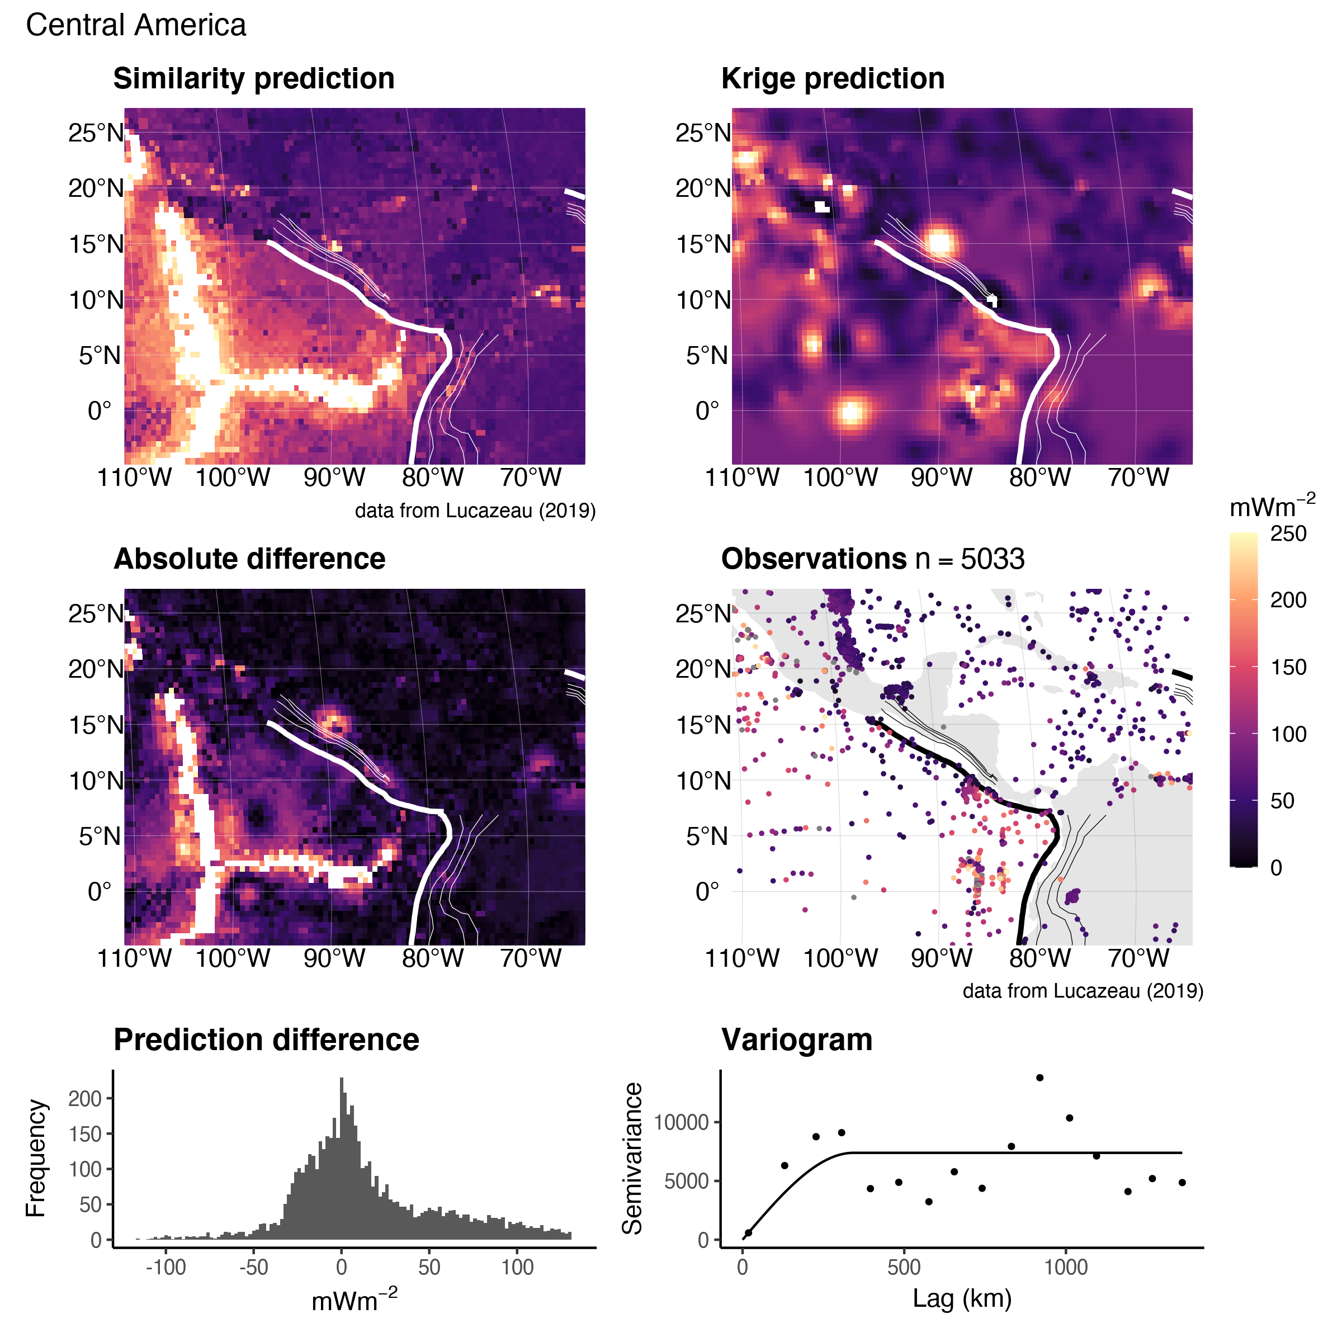

Figure 13. Similarity vs. Kriging predictions for Central America.

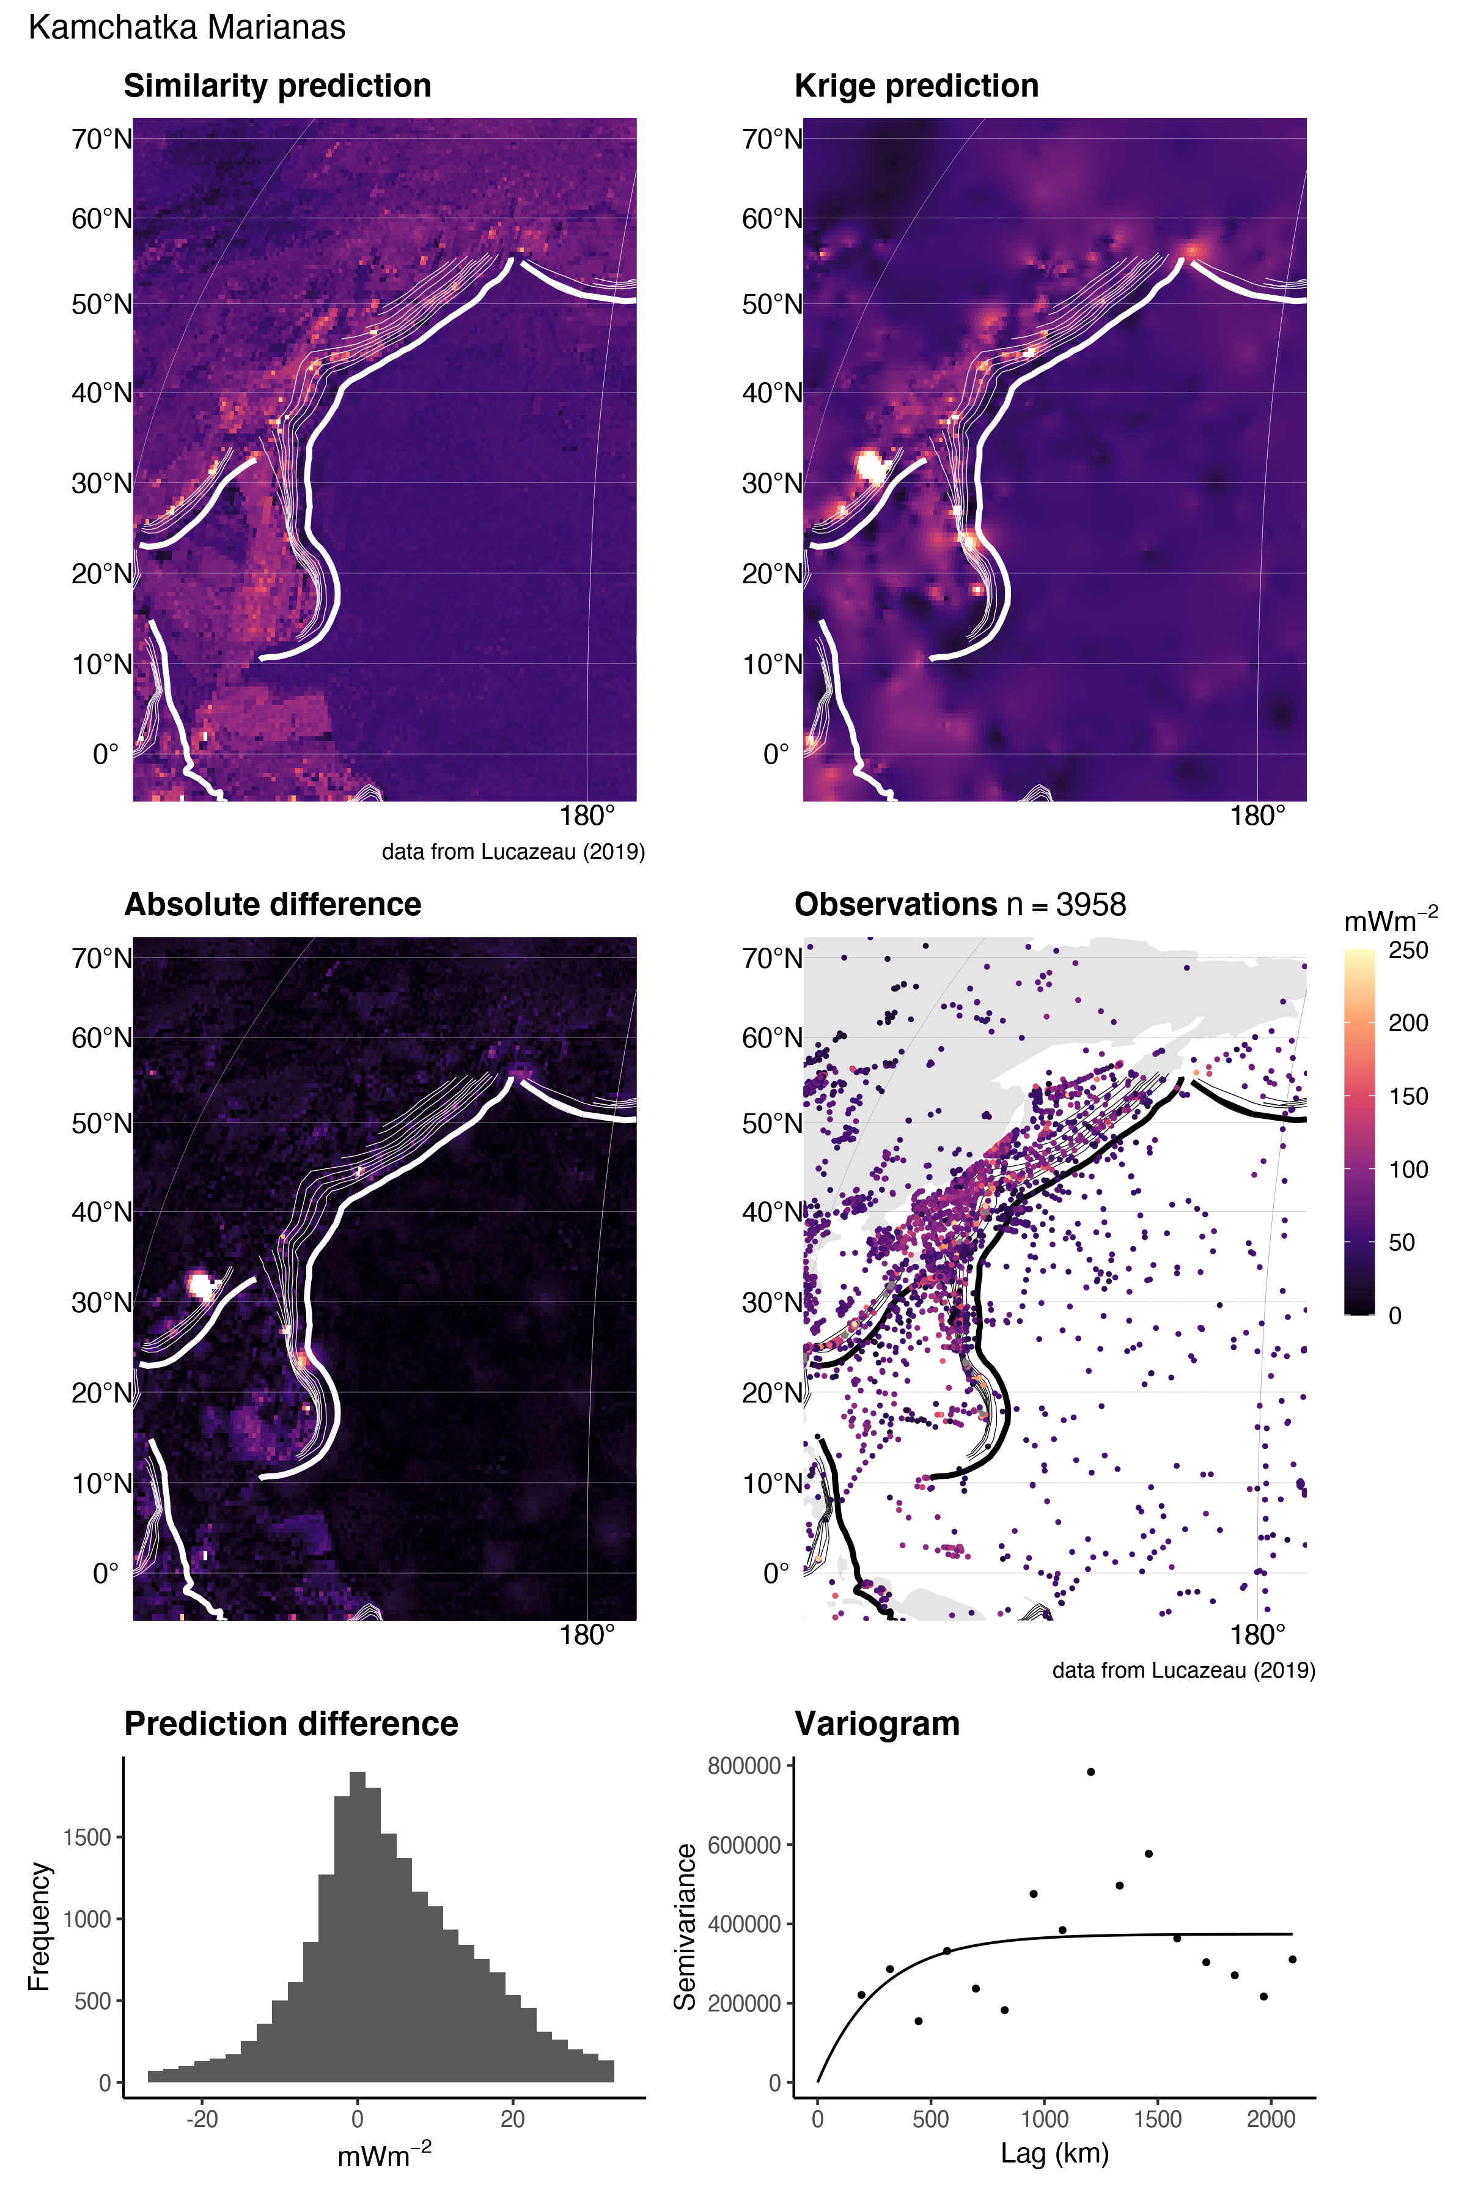

Figure 14. Similarity vs. Kriging predictions for Kamchatka Marianas.

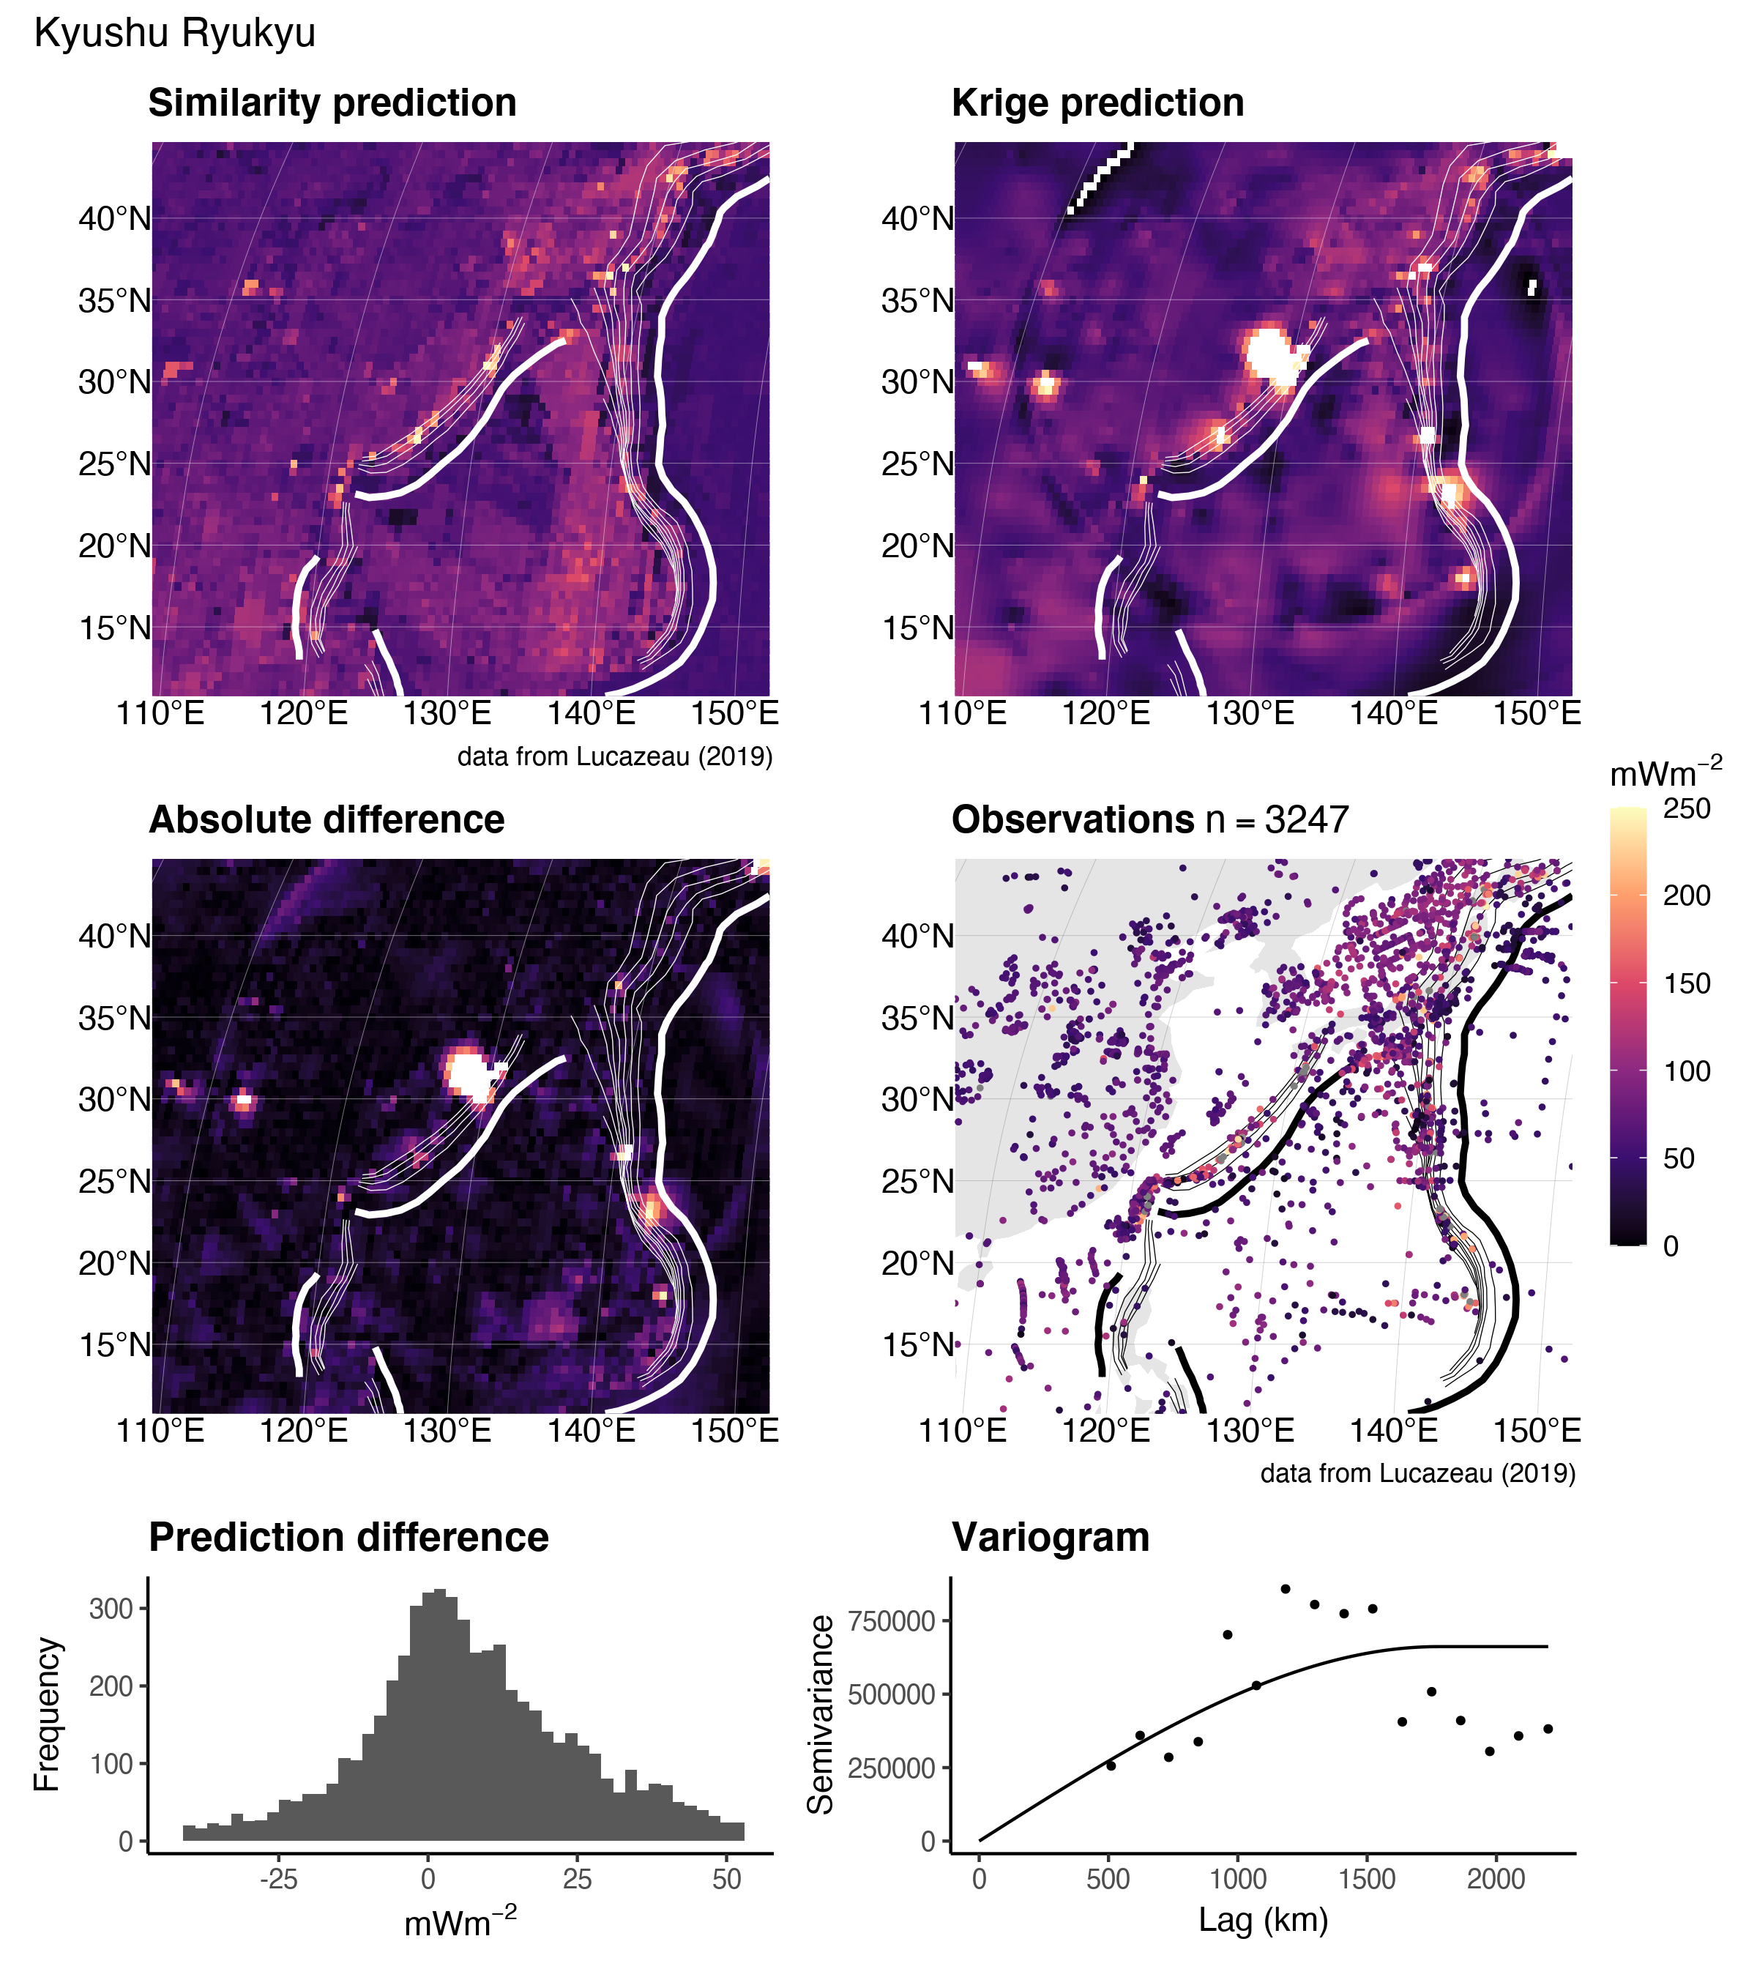

Figure 15. Similarity vs. Kriging predictions for Kyushu Ryukyu.

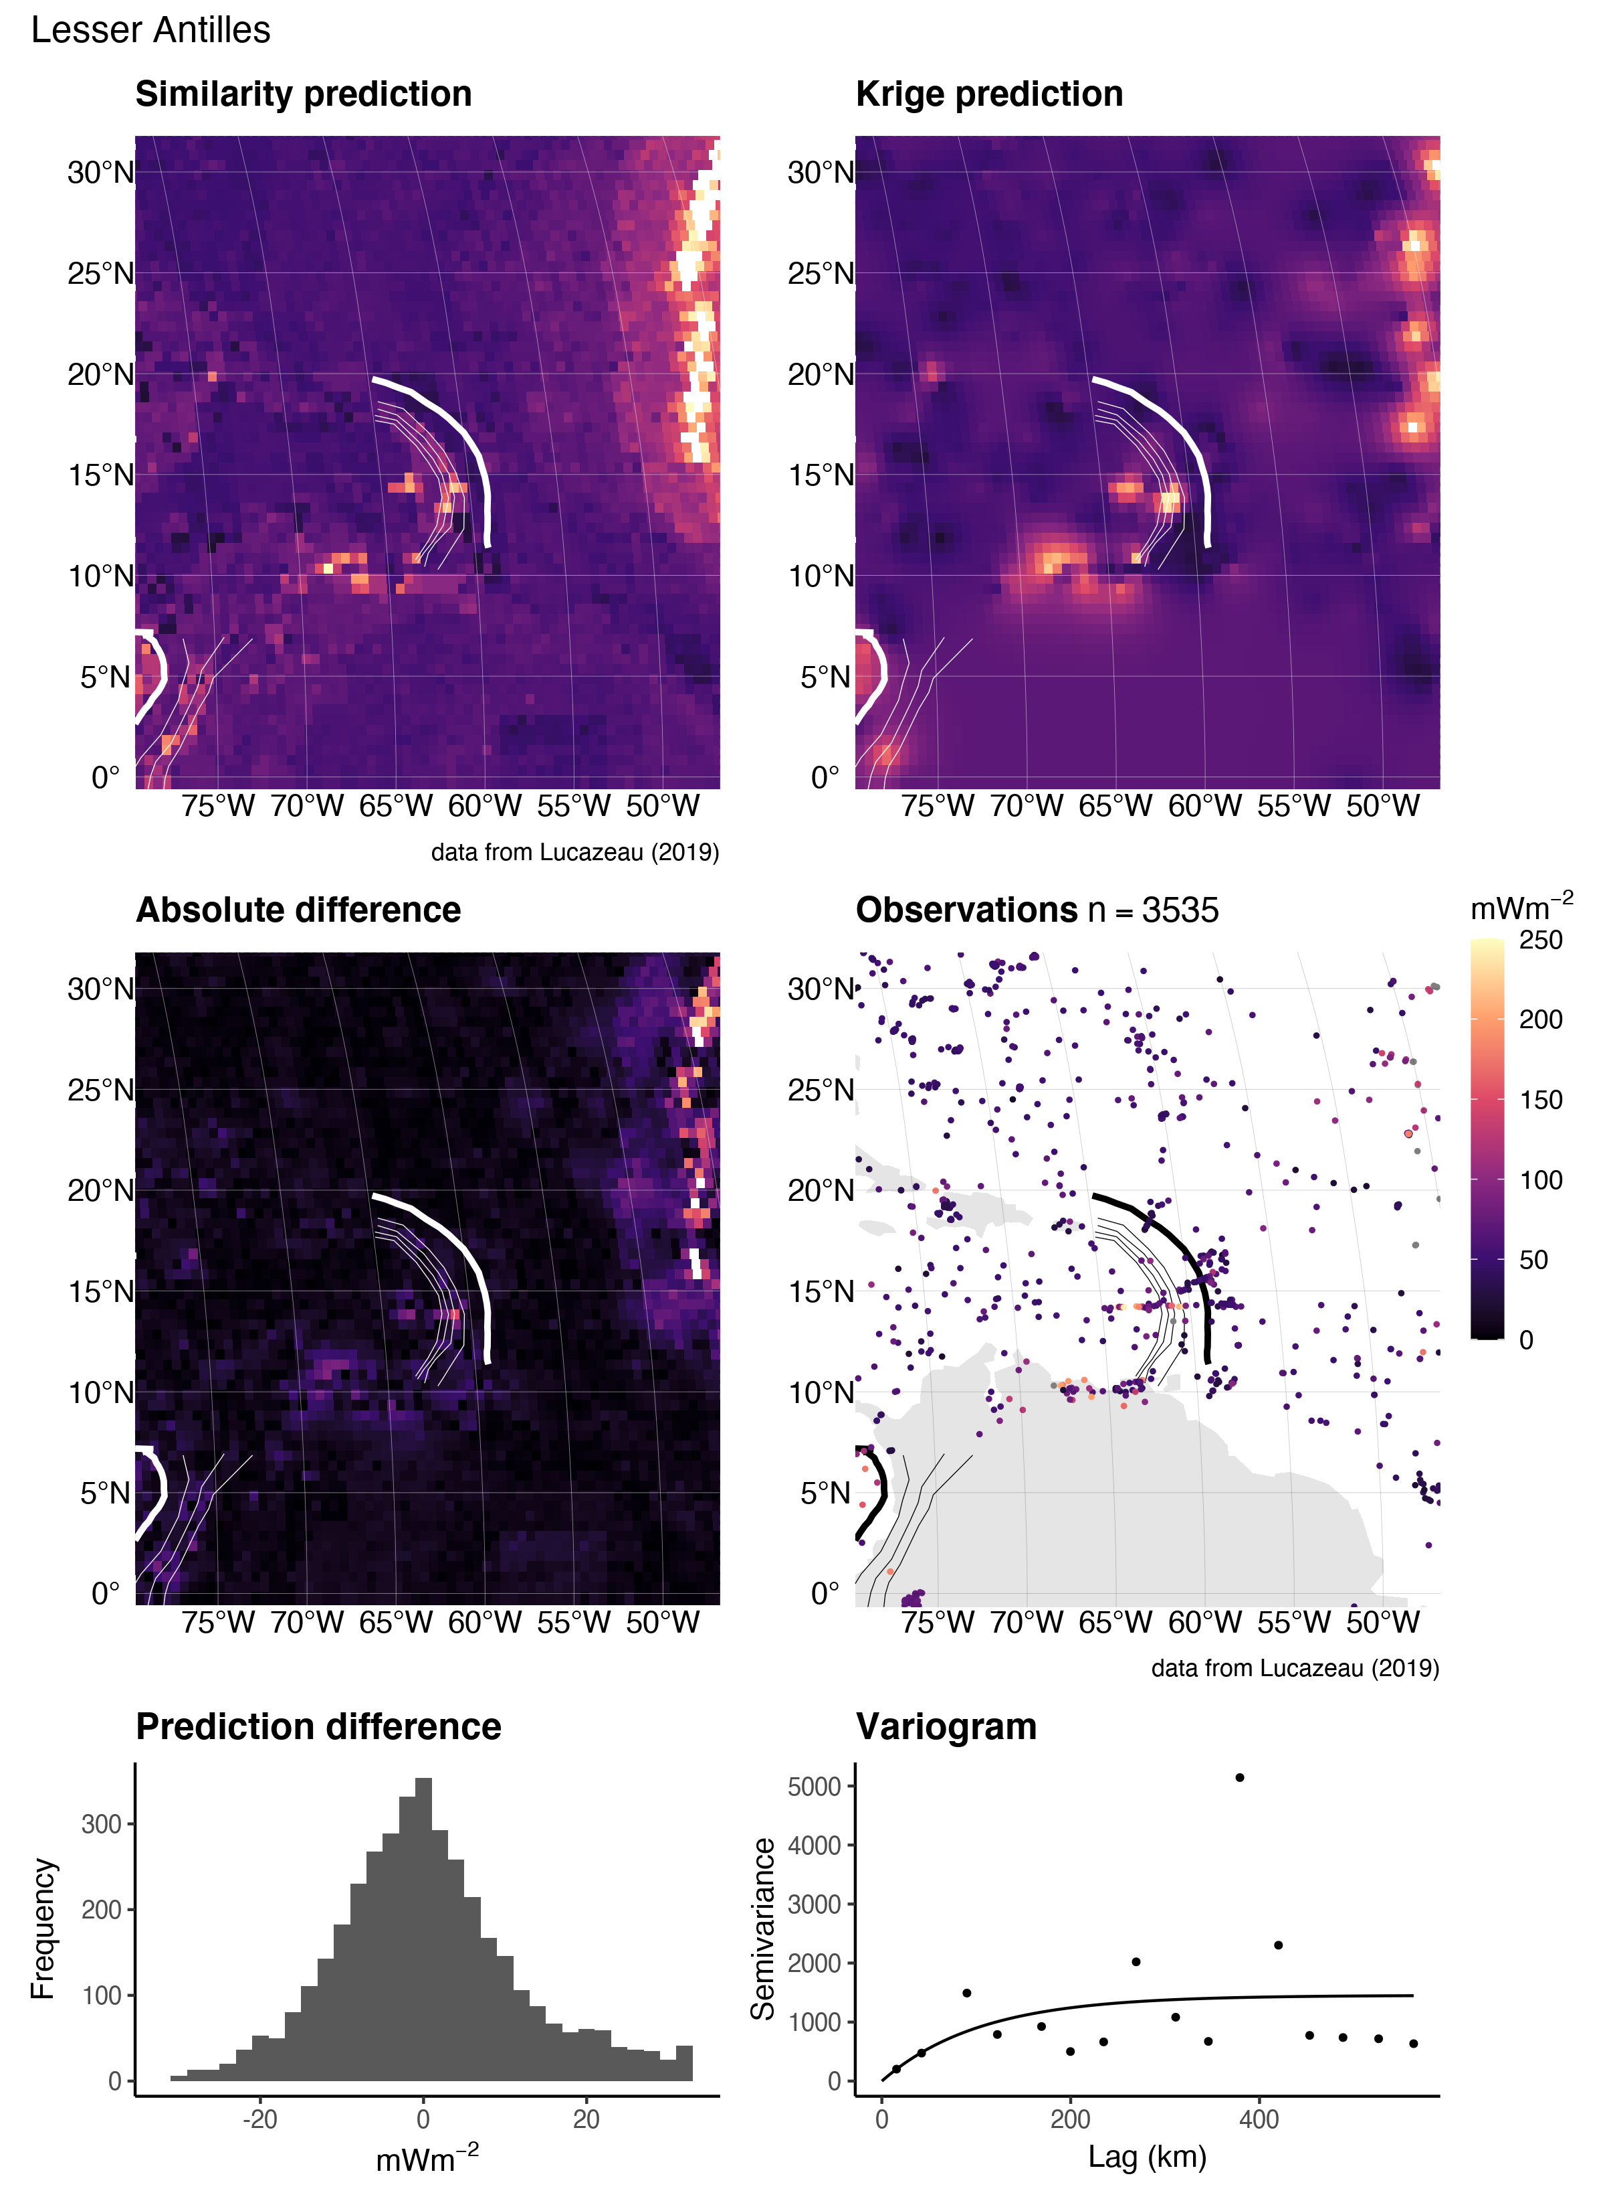

Figure 16. Similarity vs. Kriging predictions for the Lesser Antilles.

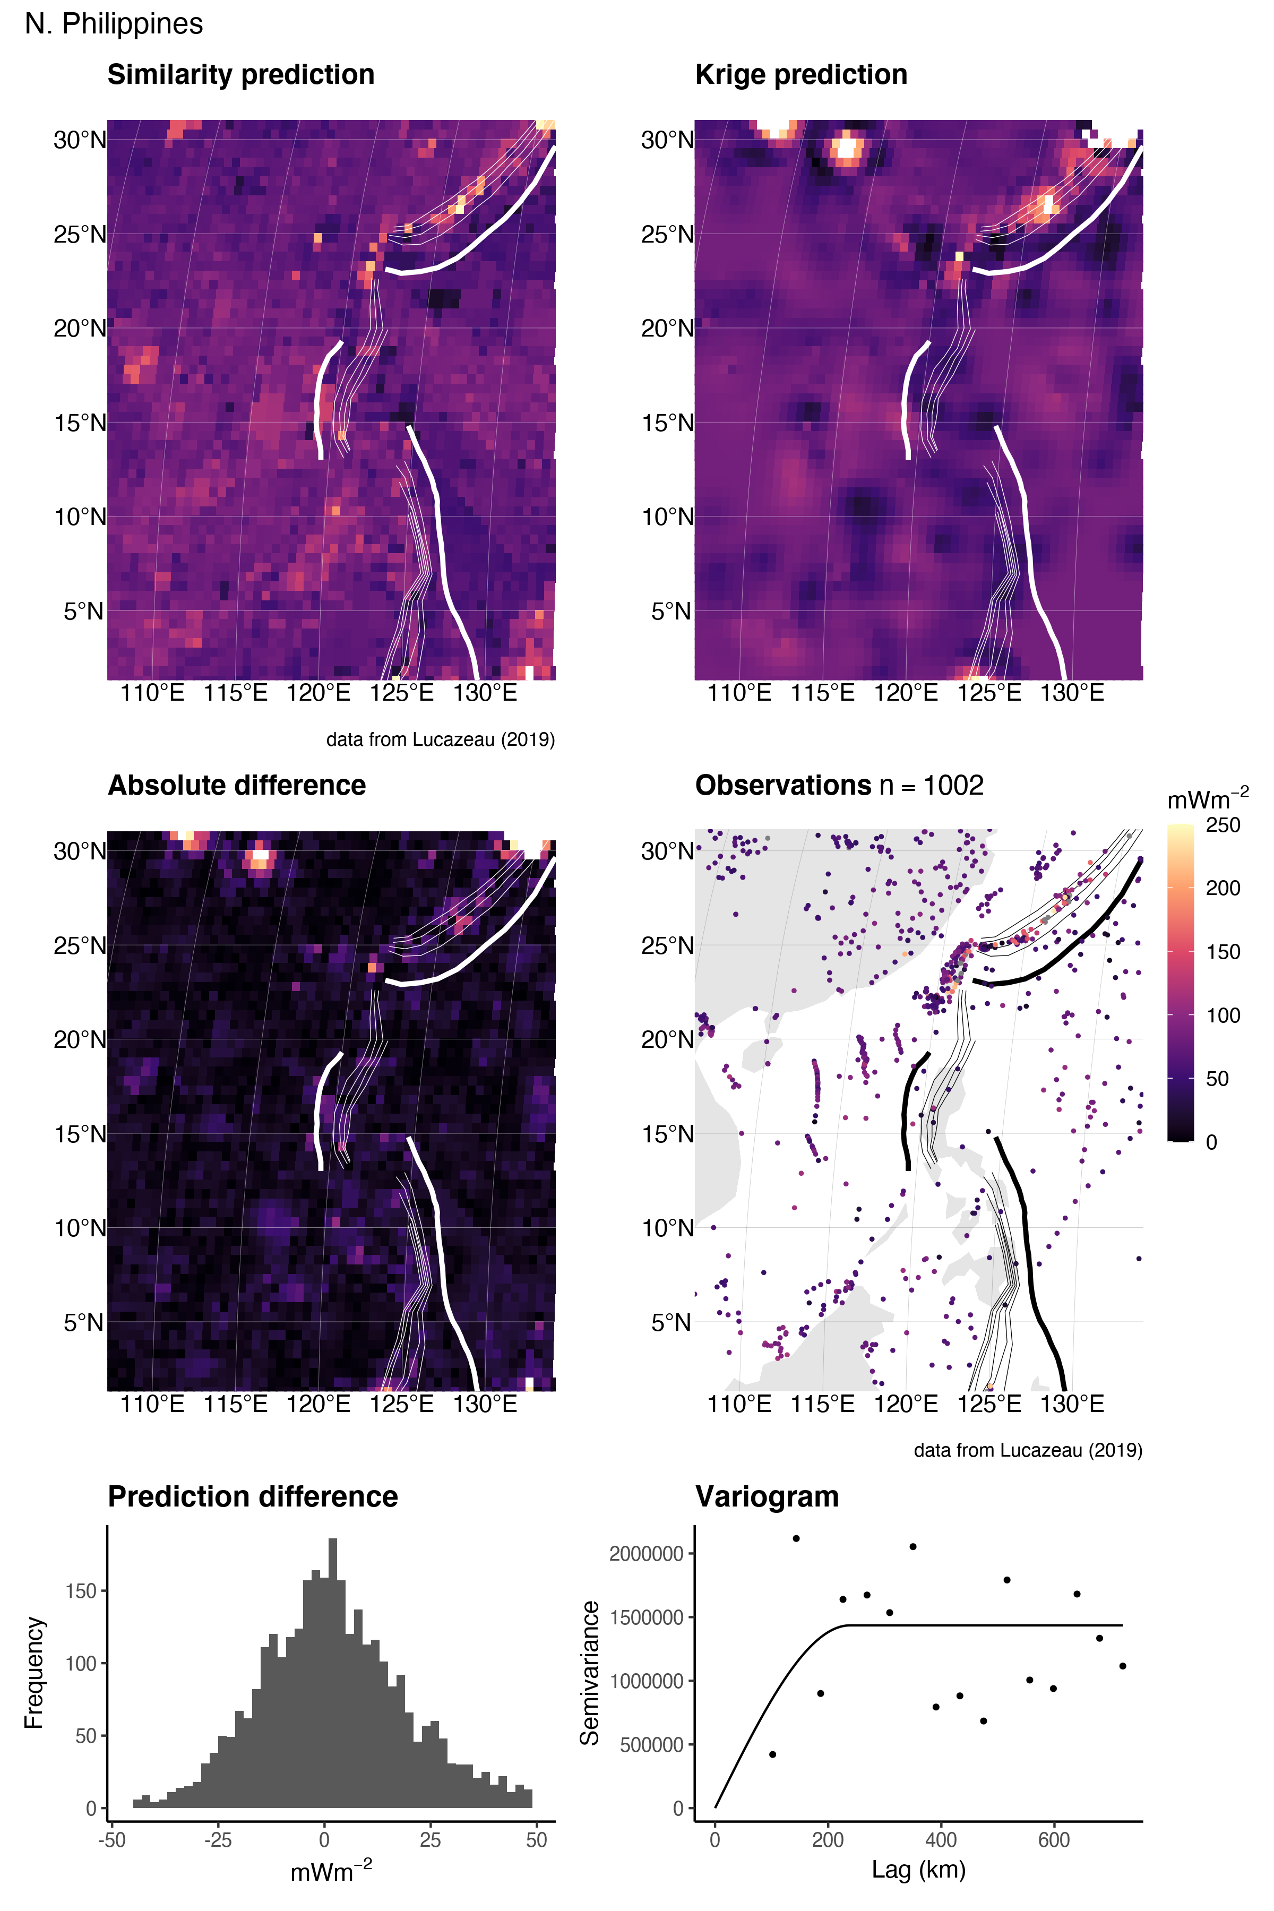

Figure 17. Similarity vs. Kriging predictions for N. Philippines.

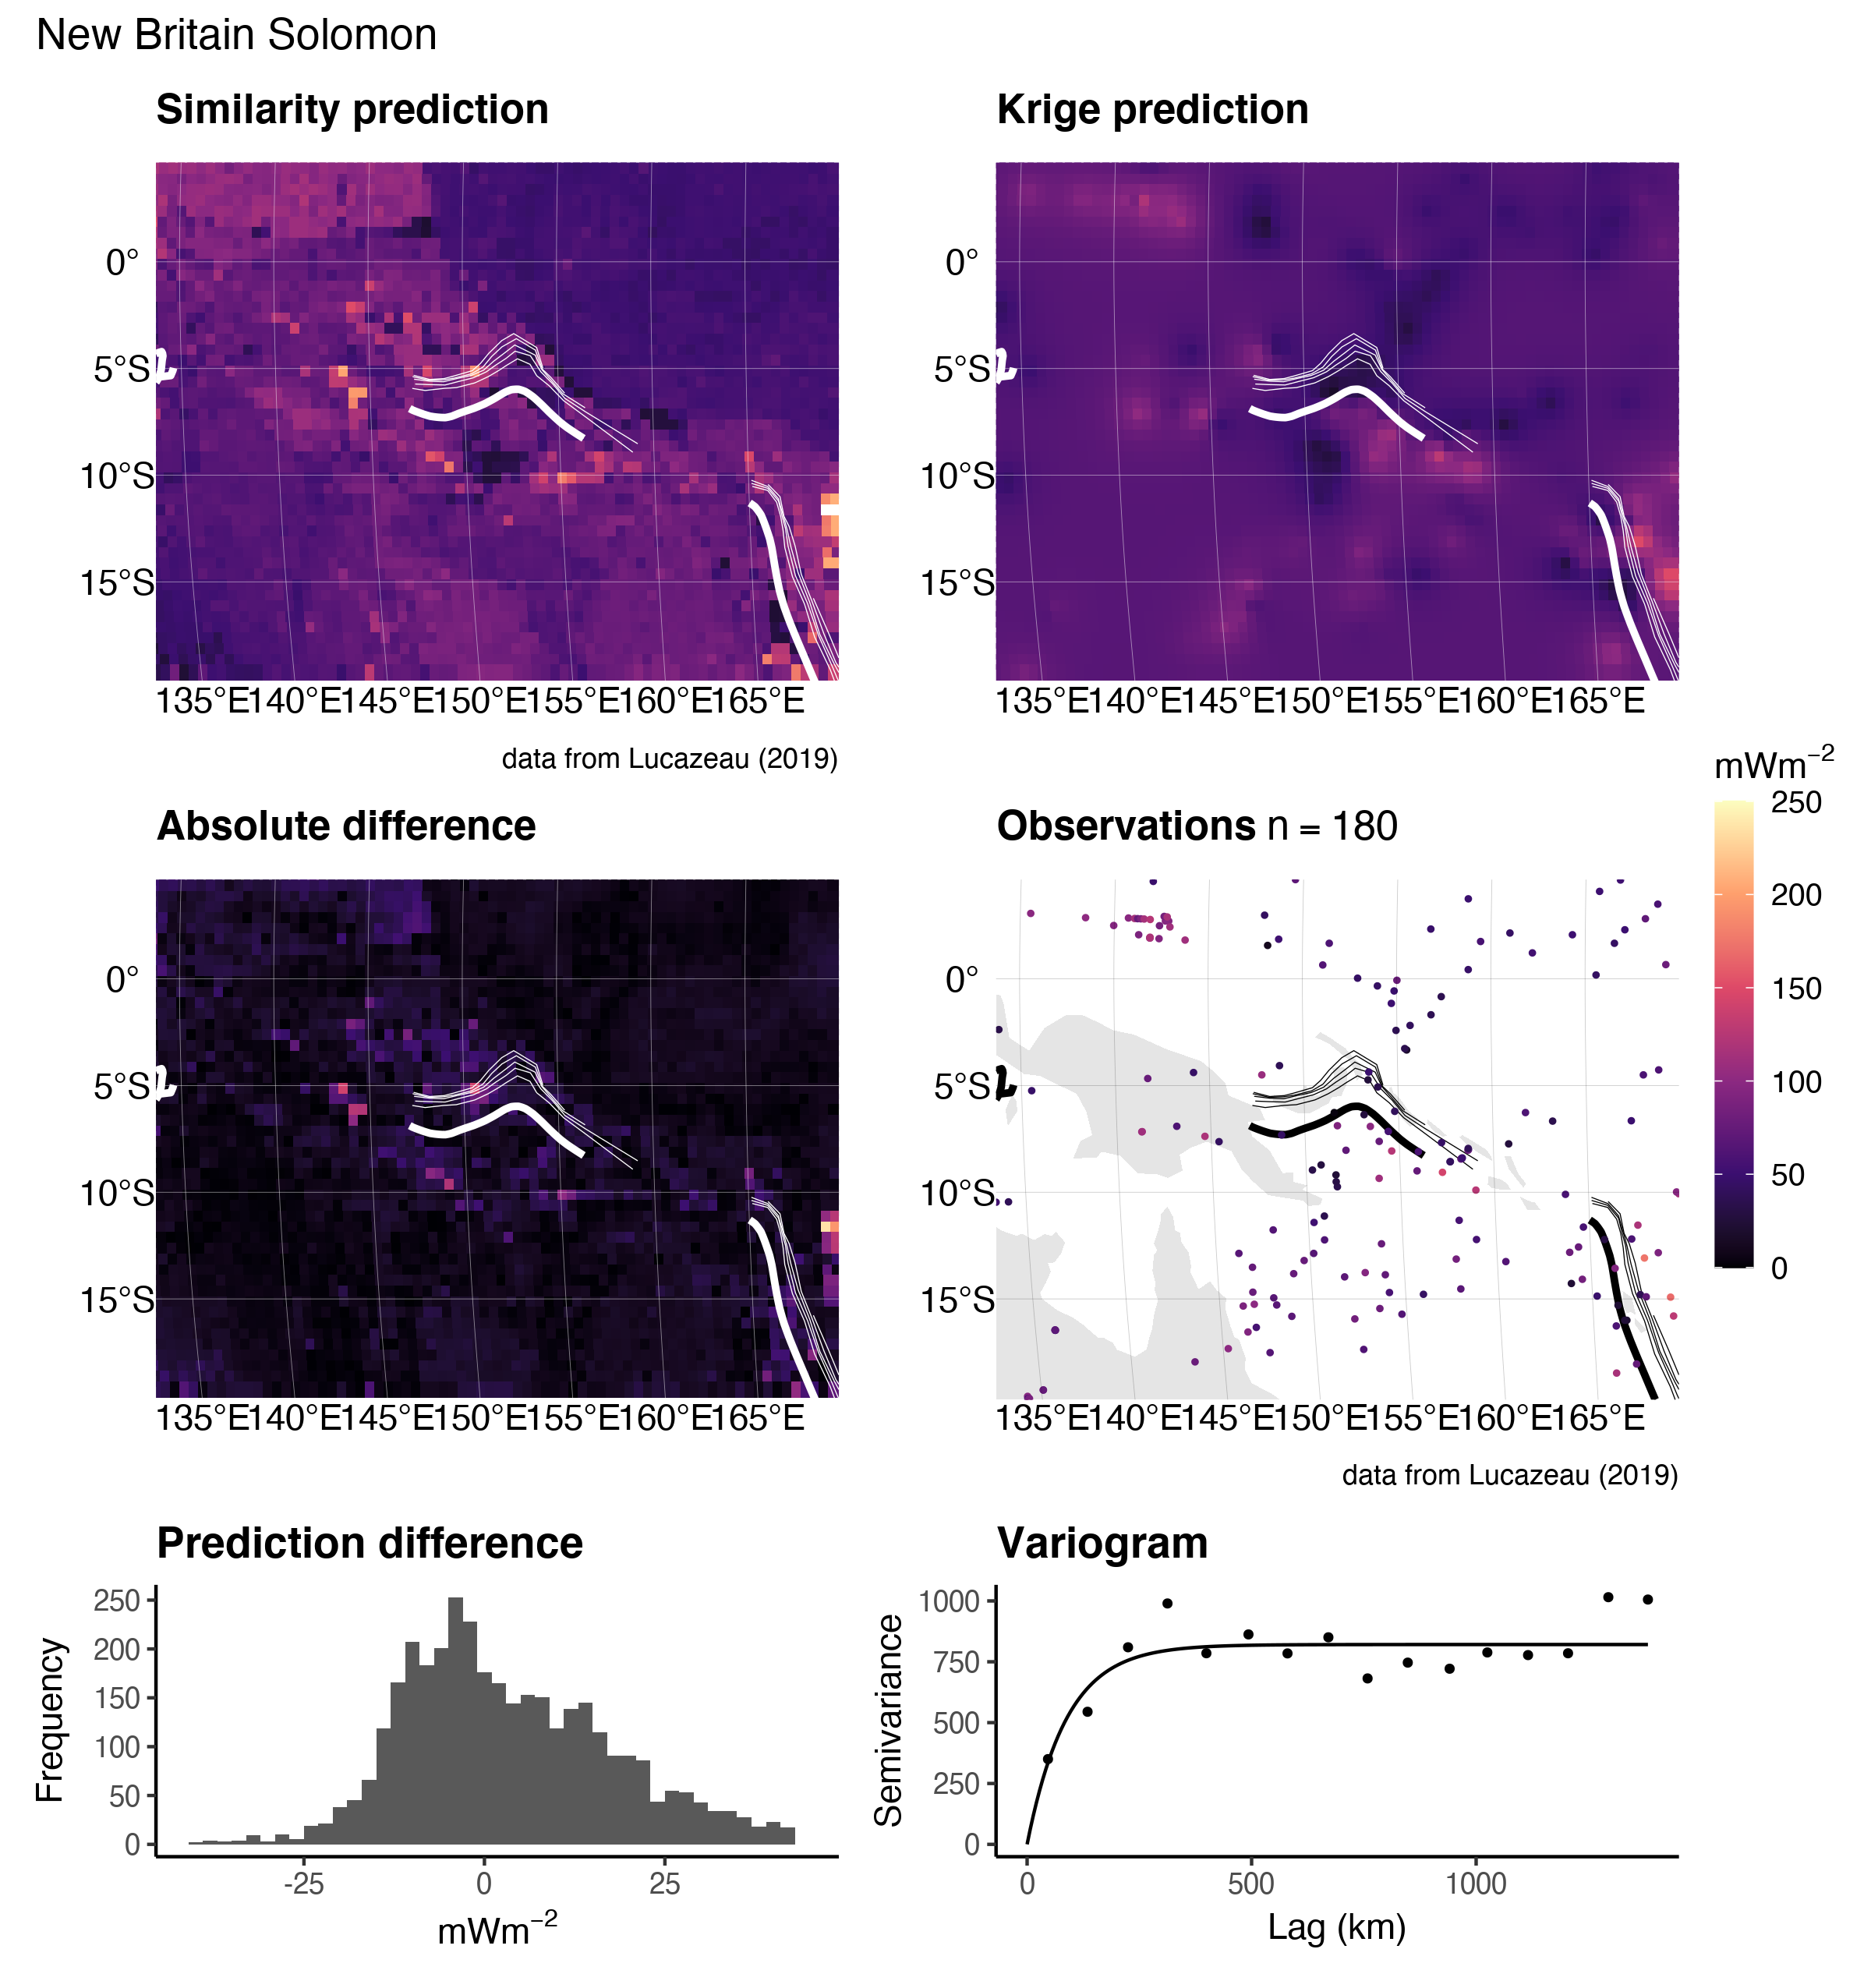

Figure 18. Similarity vs. Kriging predictions for New Britain Solomon.

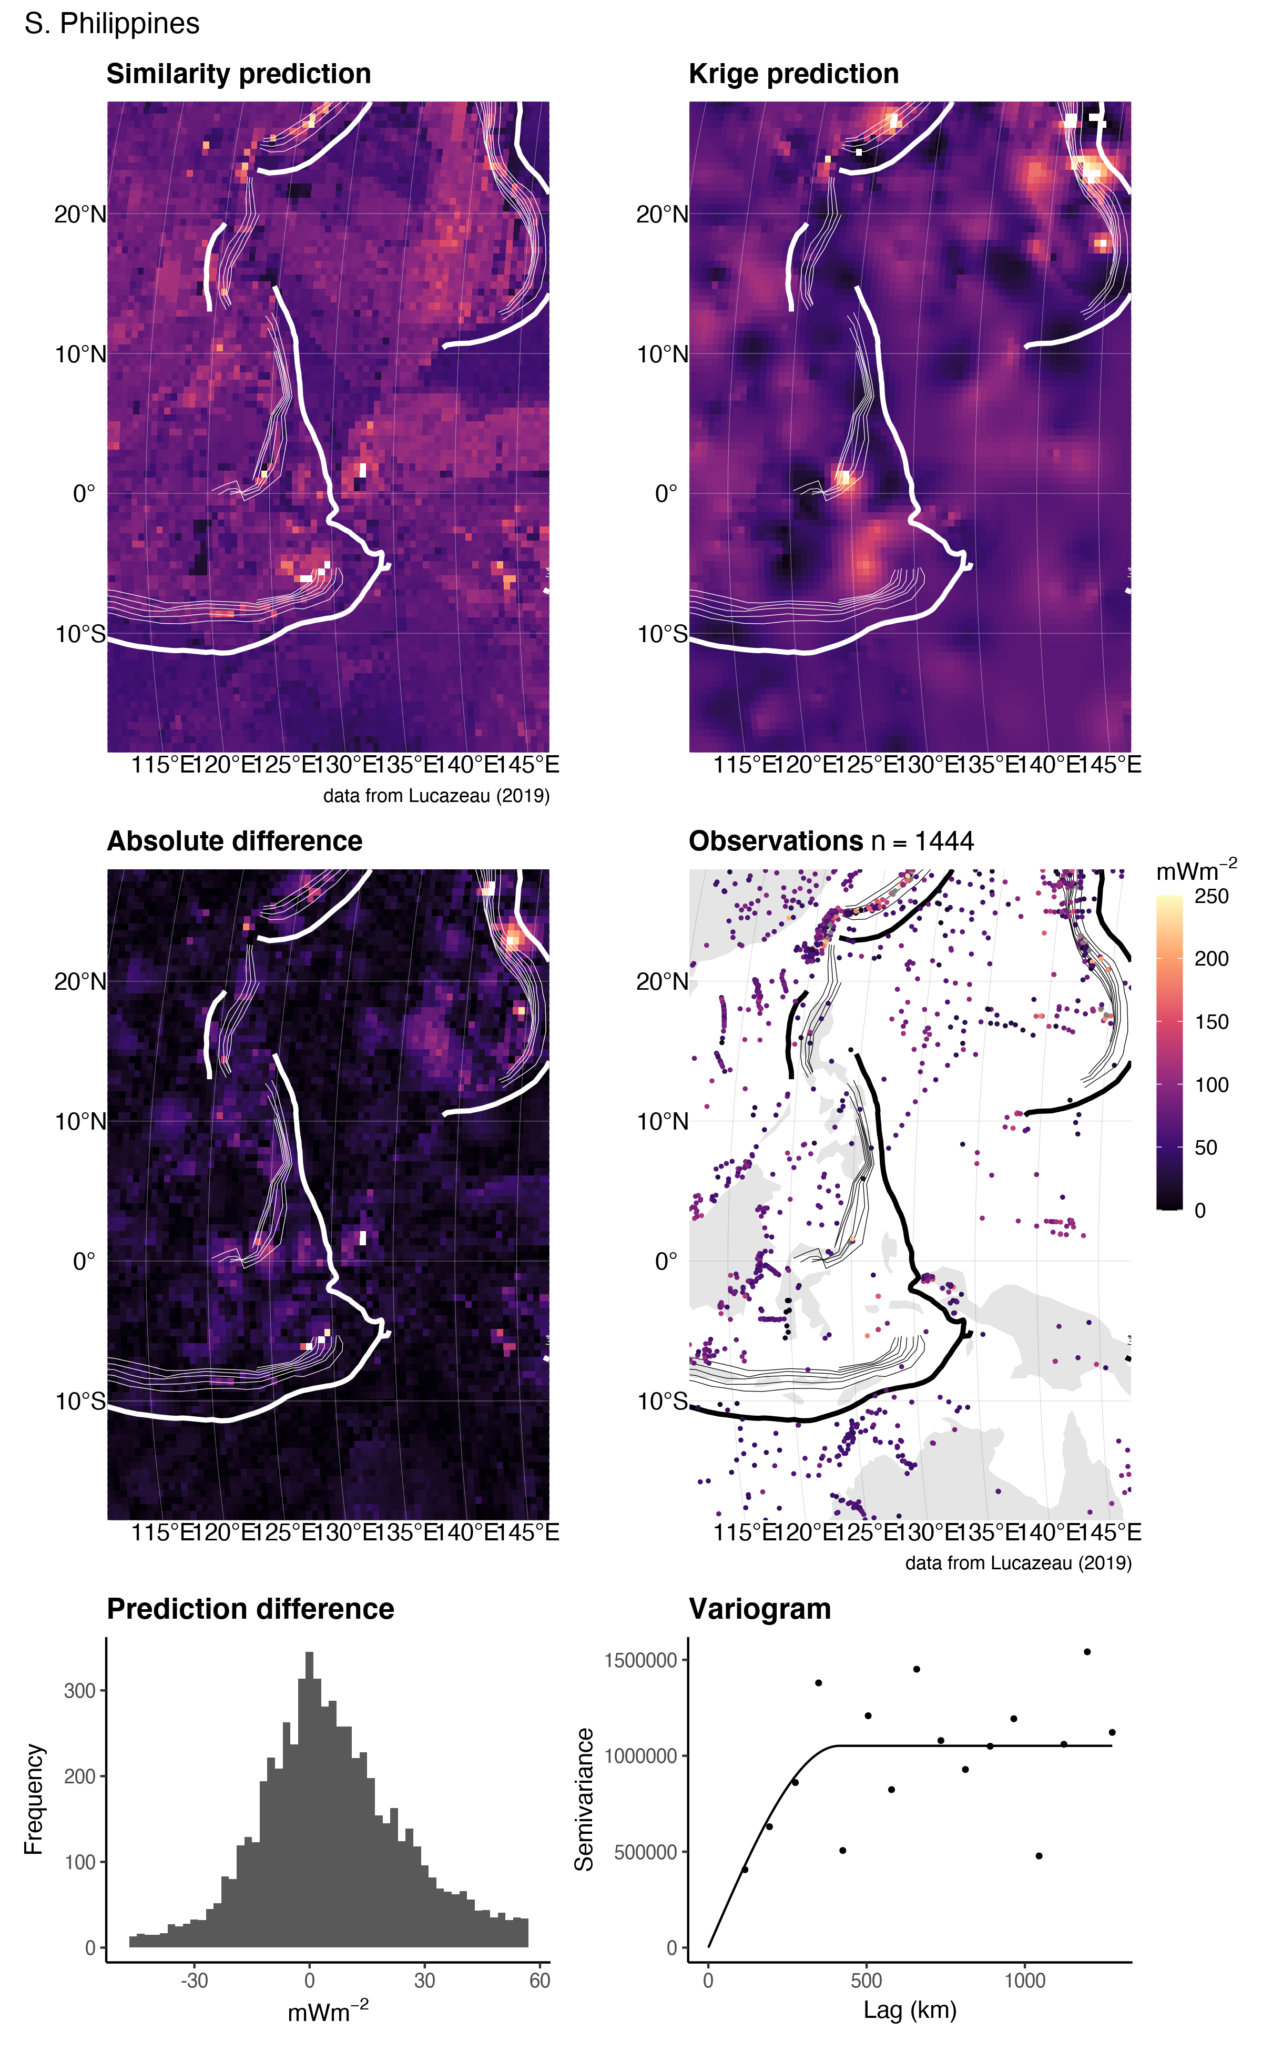

Figure 19. Similarity vs. Kriging predictions for S. Philippines.

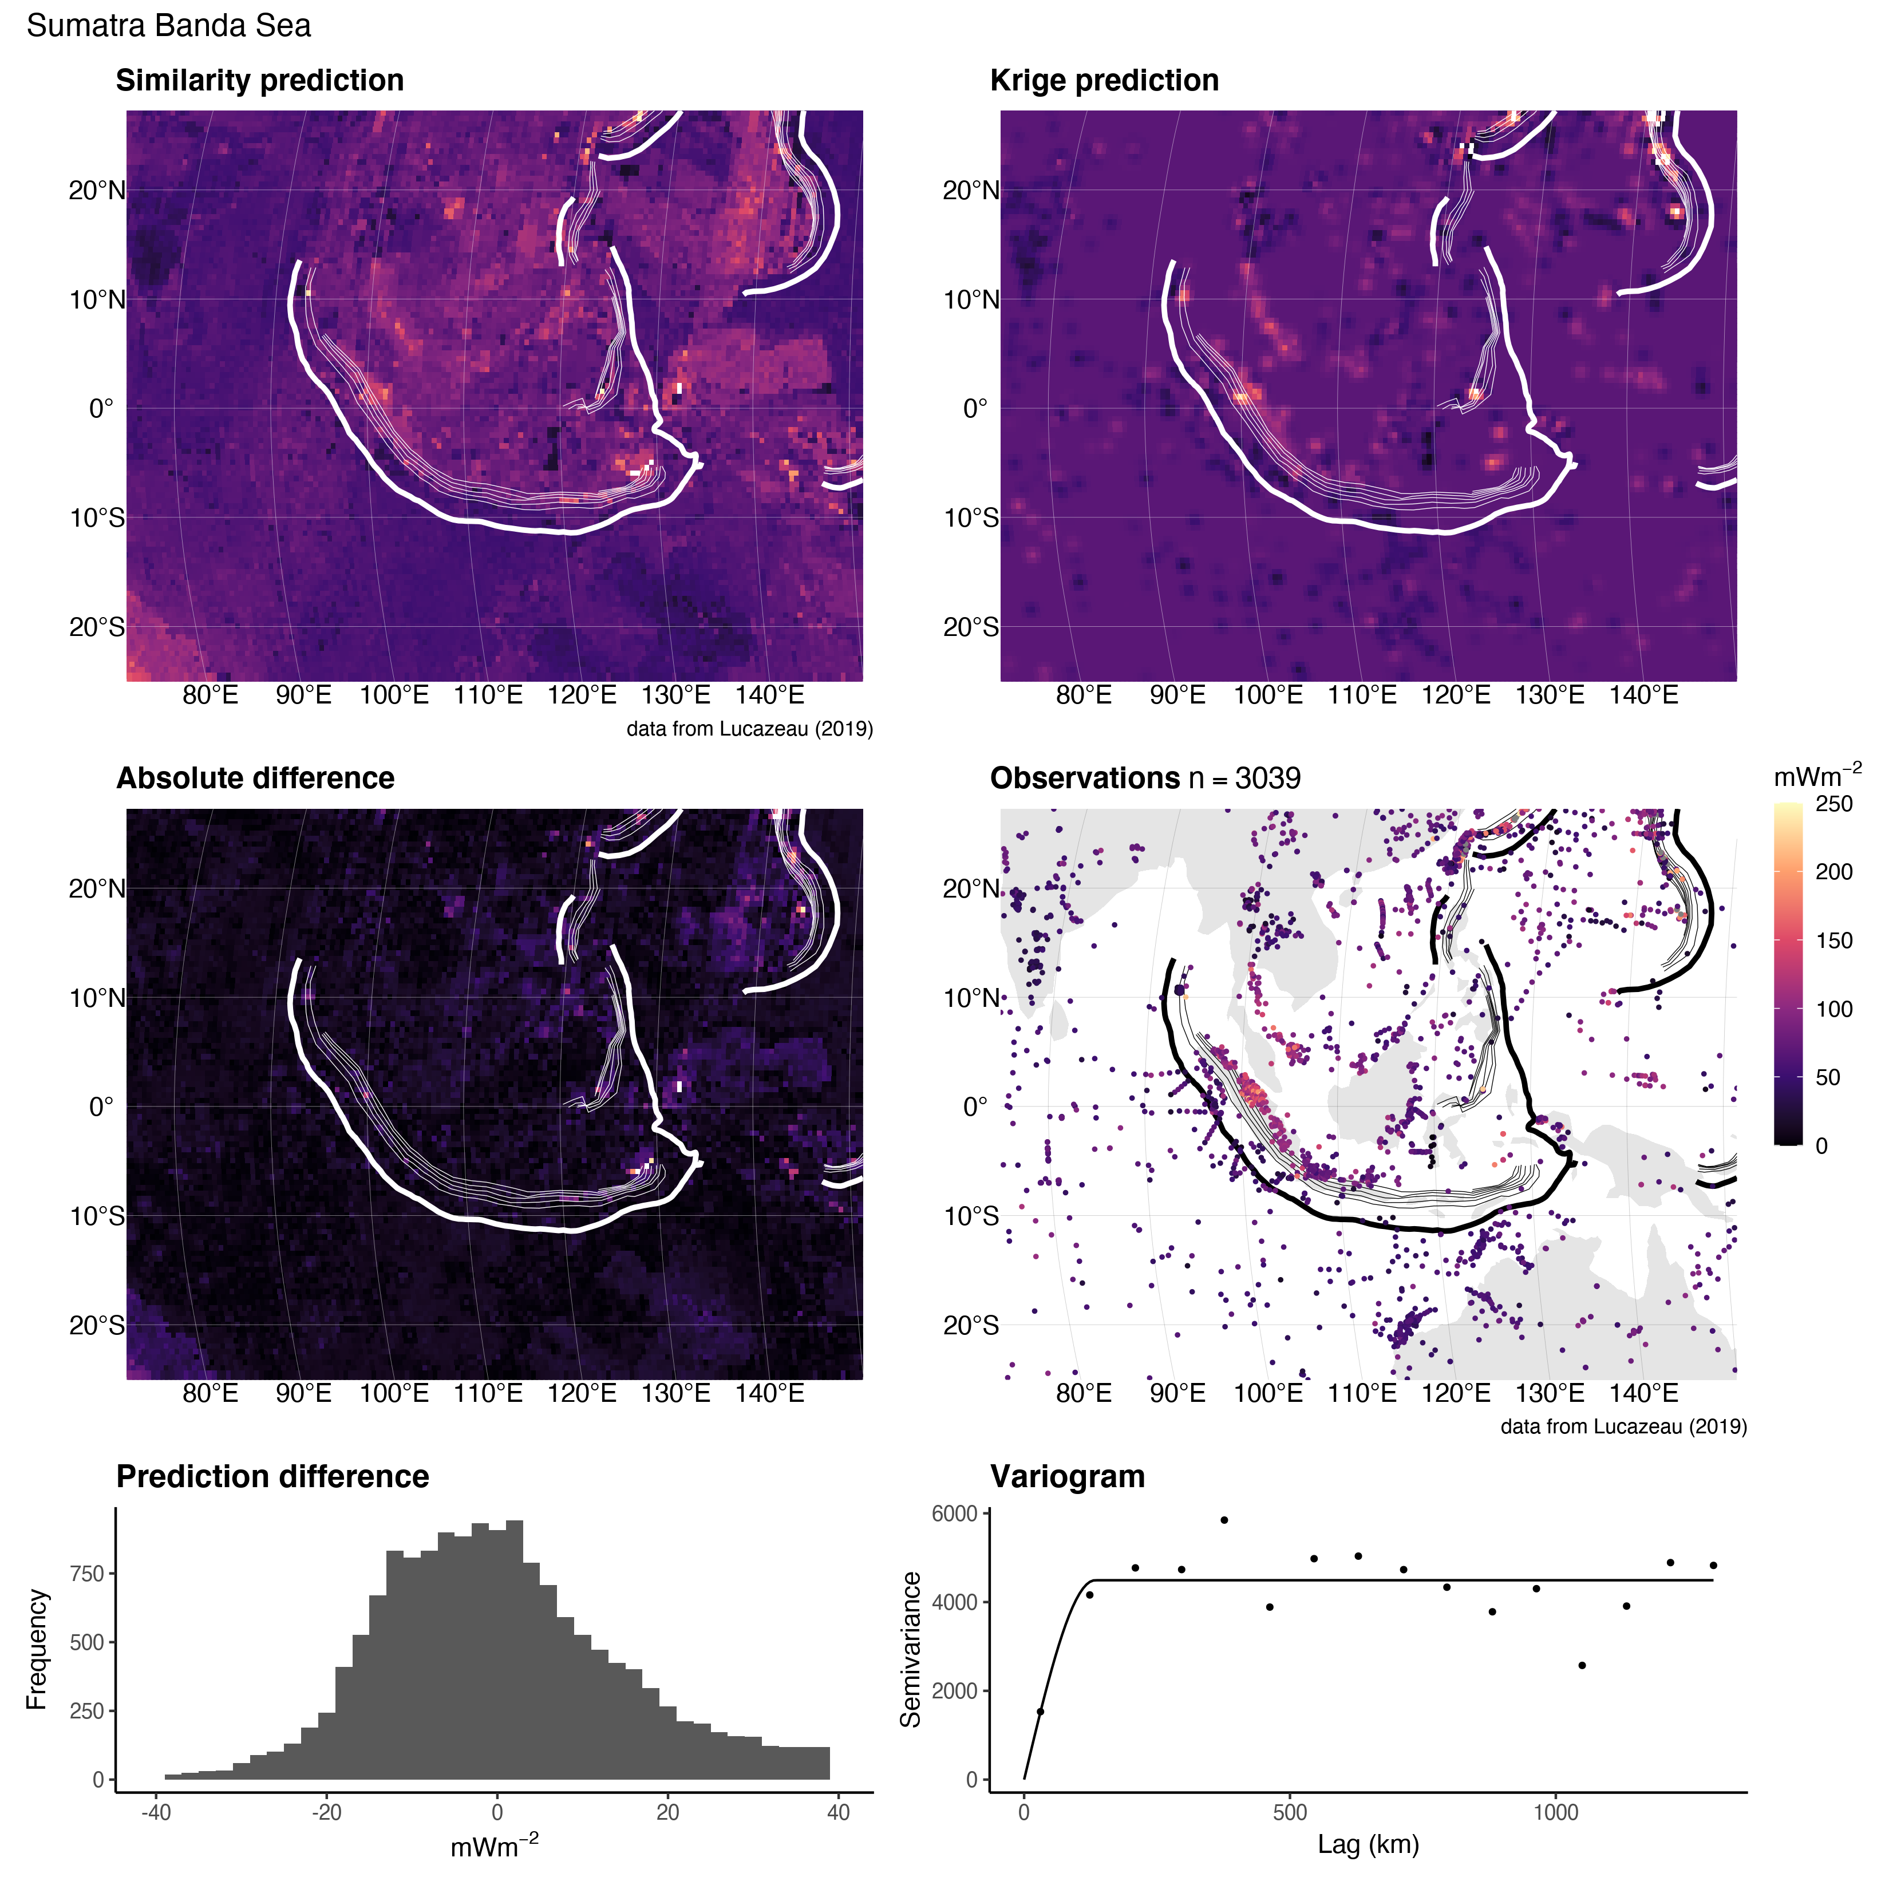

Figure 20. Similarity vs. Kriging predictions for Sumatra Banda Sea.

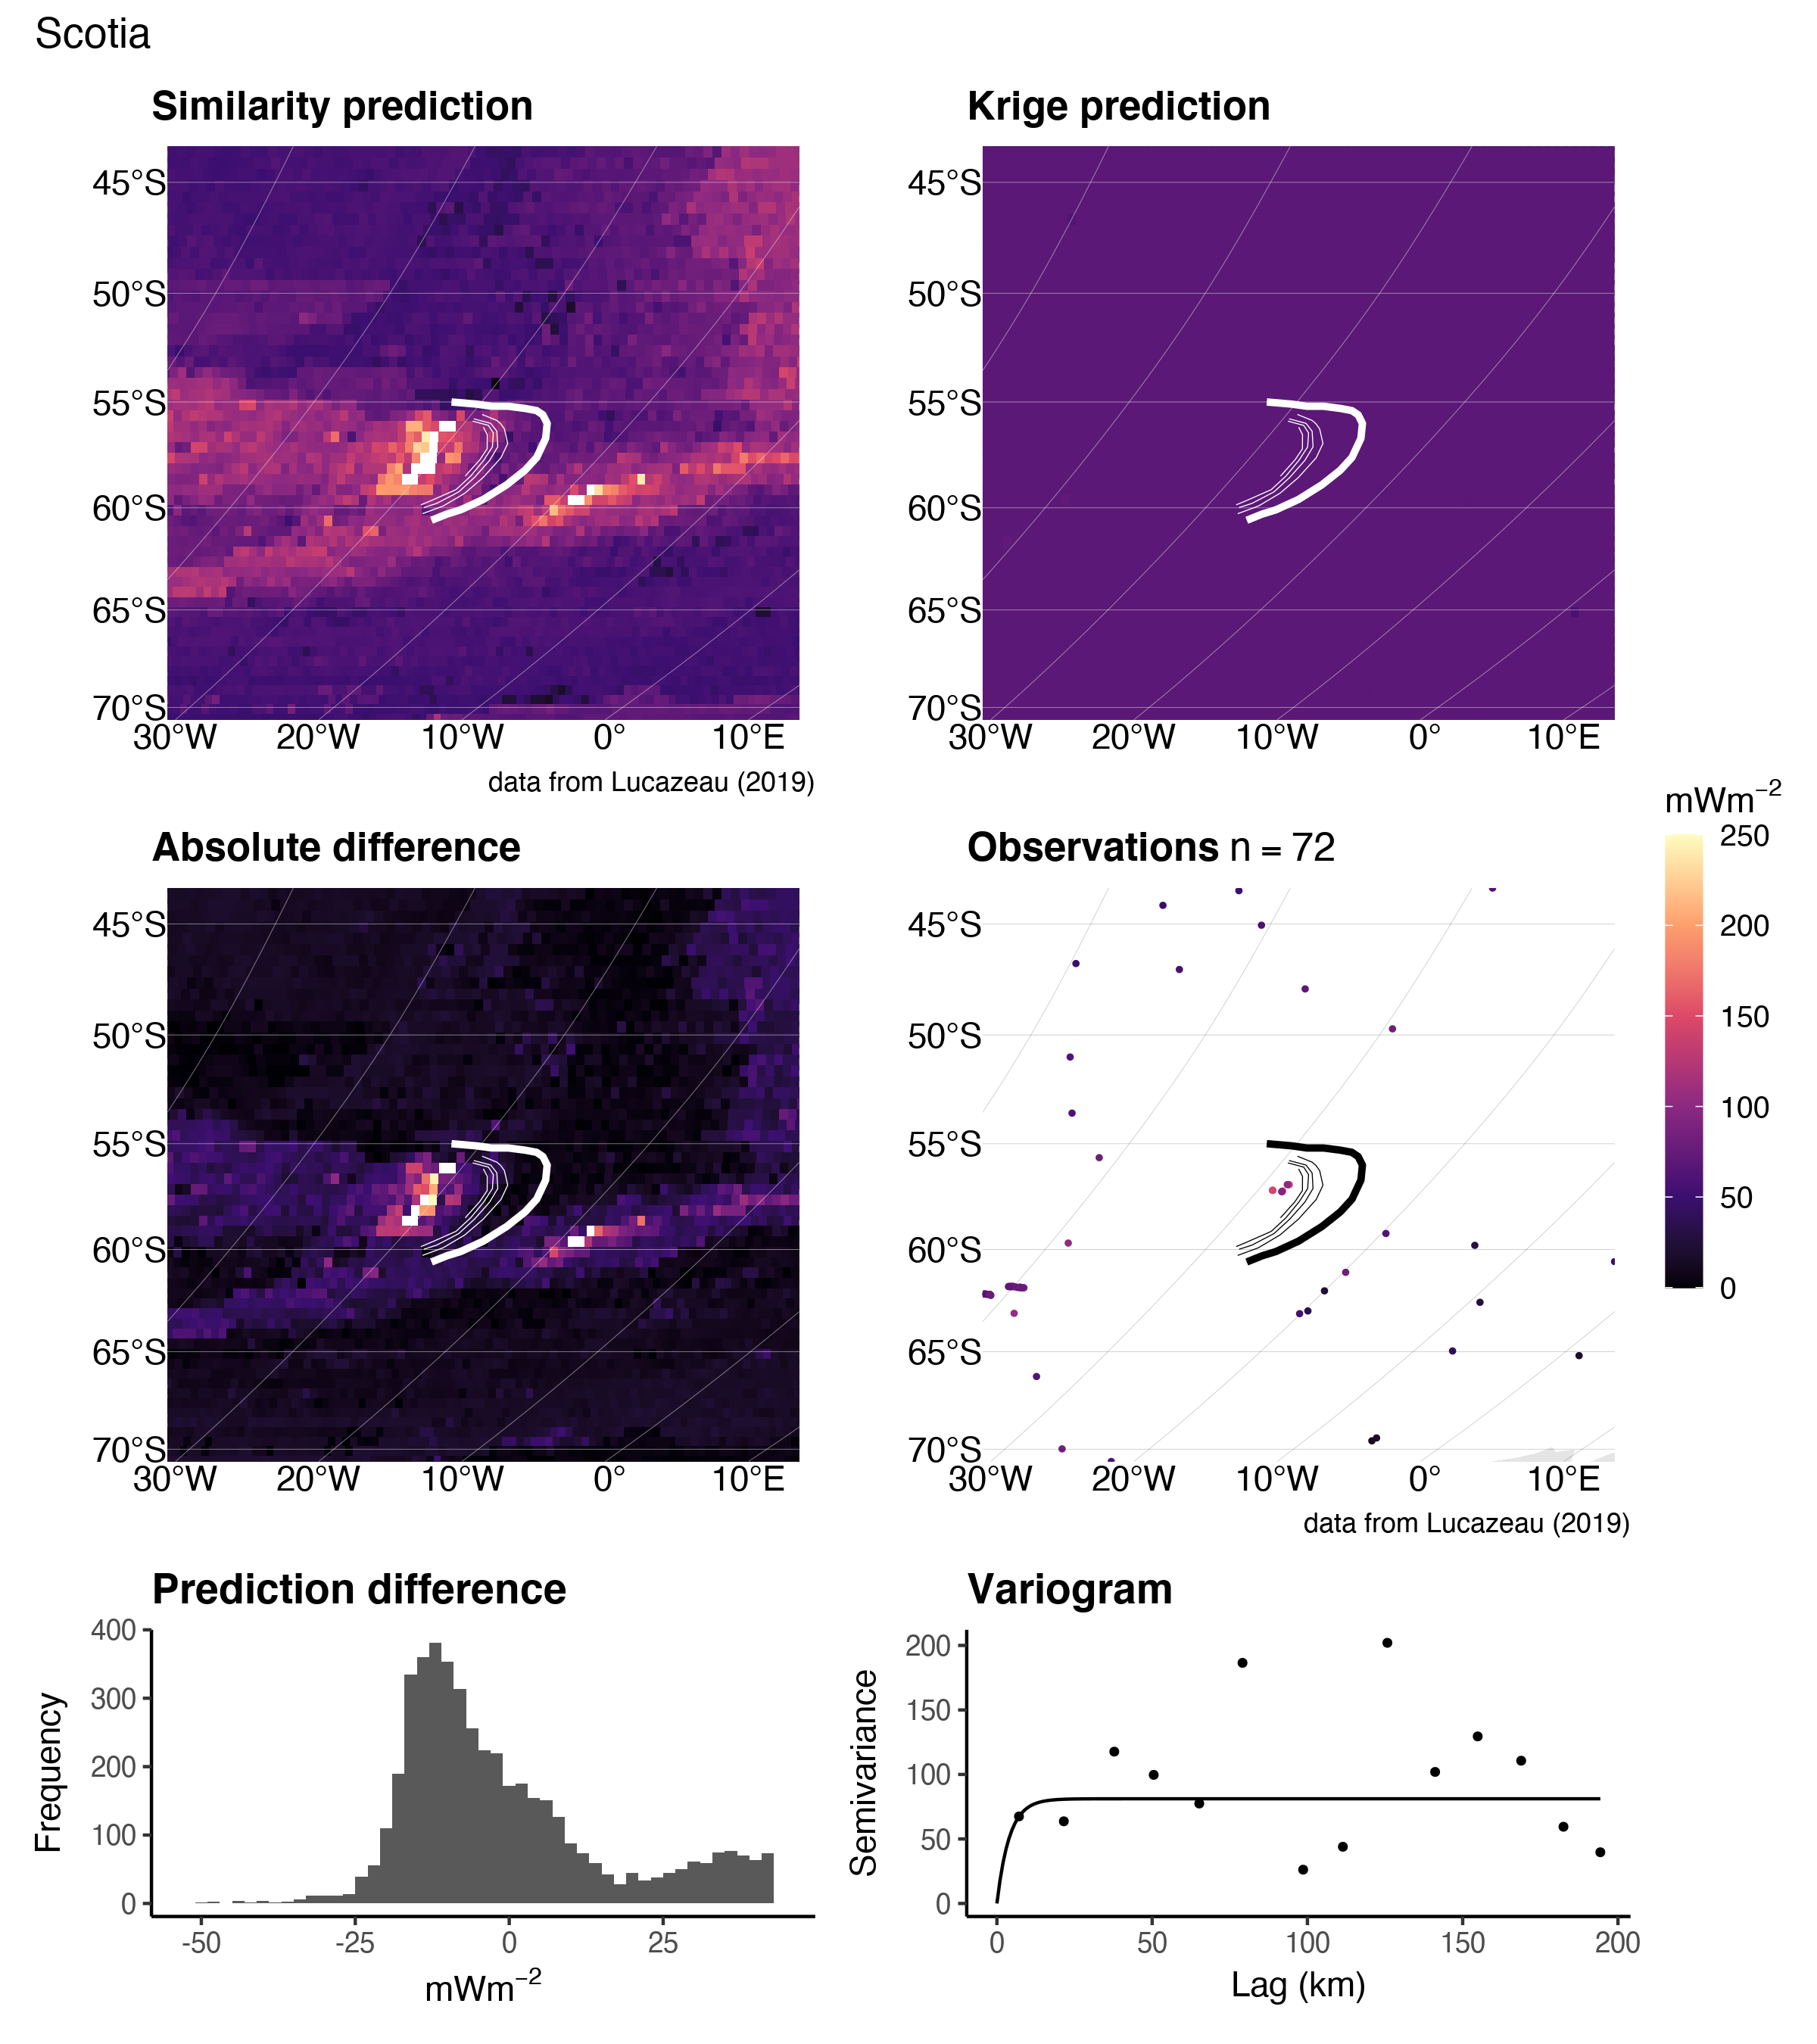

Figure 21. Similarity vs. Kriging predictions for Scotia.

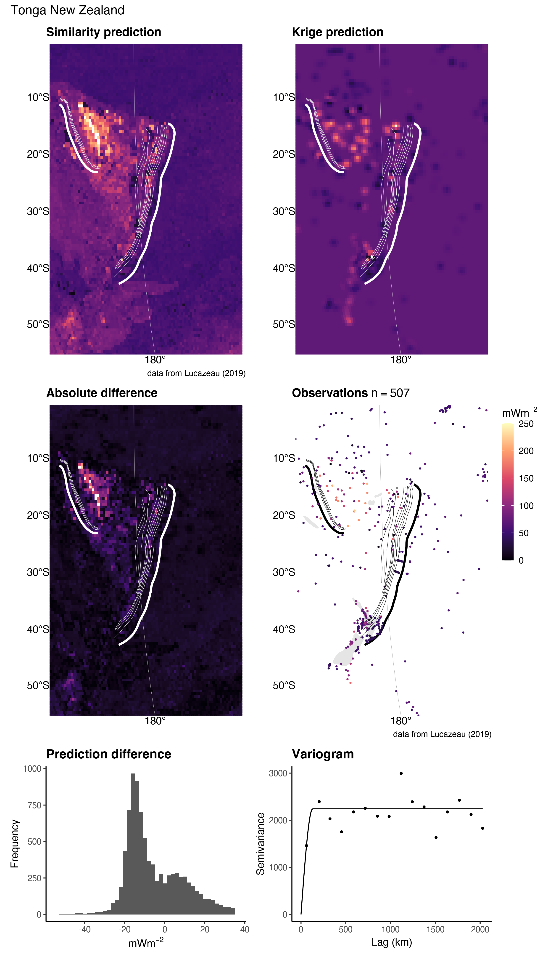

Figure 22. Similarity vs. Kriging predictions for Tonga New Zealand.

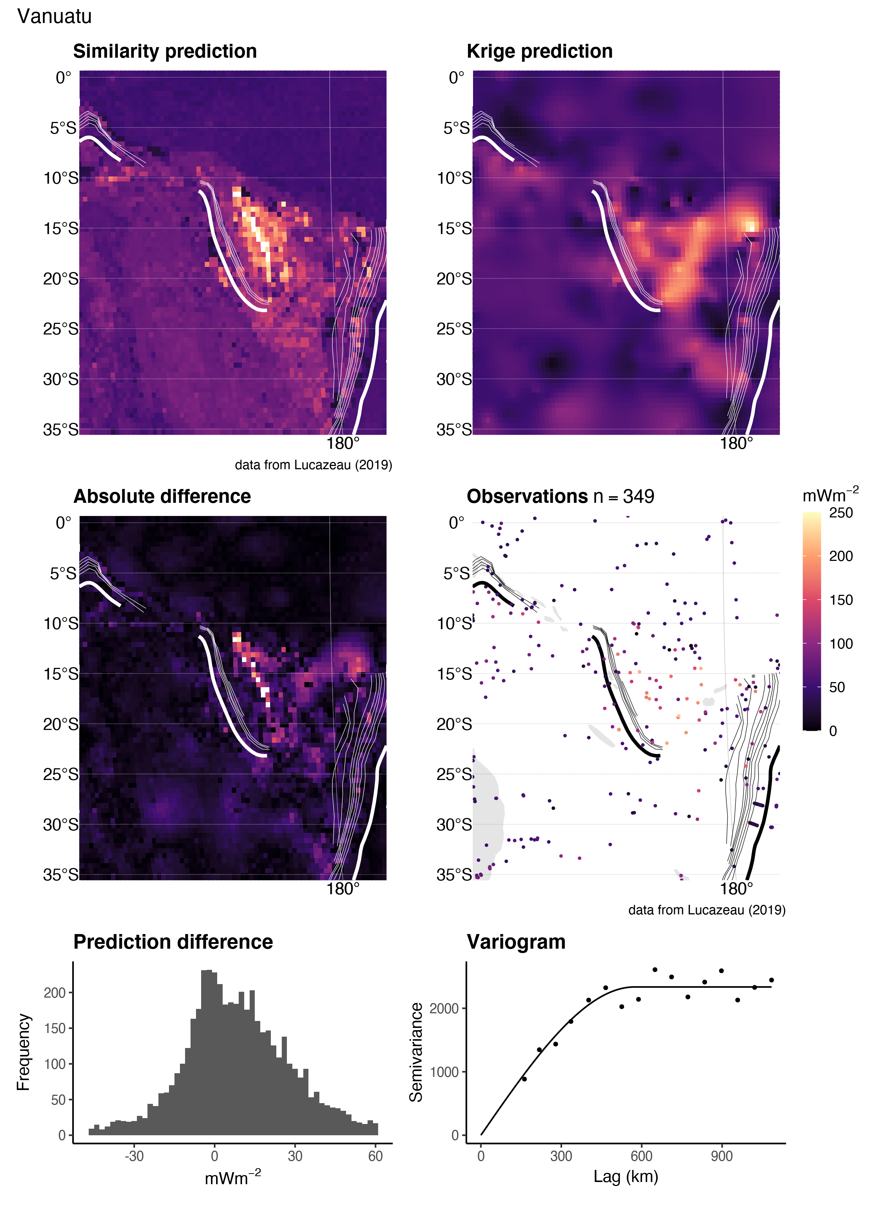

Figure 23. Similarity vs. Kriging predictions for Vanuatu.

# References

Bárdossy, A. (1997). Introduction to geostatistics. *Institute of Hydraulic Engineering, University of Stuttgart*.

Chapman, D. S., & Pollack, H. N. (1975). Global heat flow: A new look. *Earth and Planetary Science Letters*, *28*(1), 23–32.

Chiles, J.-P., & Delfiner, P. (2009). *Geostatistics: Modeling spatial uncertainty* (Vol. 497). John Wiley & Sons.

Cressie, N. (2015). *Statistics for spatial data*. John Wiley & Sons.

Currie, C., & Hyndman, R. D. (2006). The thermal structure of subduction zone back arcs. *Journal of Geophysical Research: Solid Earth*, *111*(B8).

Currie, C., Wang, K., Hyndman, R. D., & He, J. (2004). The thermal effects of steady-state slab-driven mantle flow above a subducting plate: The cascadia subduction zone and backarc. *Earth and Planetary Science Letters*, *223*(1-2), 35–48.

Davies, J. H. (2013). Global map of solid earth surface heat flow. *Geochemistry, Geophysics, Geosystems*, *14*(10), 4608–4622.

Fourier, J. (1827). Mémoire sur les températures du globe terrestre et des espaces planétaires. *Mémoires de l’Académie Royale Des Sciences de l’Institut de France*, *7*, 570–604.

Furlong, K. P., & Chapman, D. S. (2013). Heat flow, heat generation, and the thermal state of the lithosphere. *Annual Review of Earth and Planetary Sciences*, *41*, 385–410.

Furukawa, Y. (1993). Depth of the decoupling plate interface and thermal structure under arcs. *Journal of Geophysical Research: Solid Earth*, *98*(B11), 20005–20013.

Gao, X., & Wang, K. (2014). Strength of stick-slip and creeping subduction megathrusts from heat flow observations. *Science*, *345*(6200), 1038–1041.

Goldberg, D. E. (1989). Genetic algorithms in search. *Optimization, and MachineLearning*.

Goodchild, M. F. (2004). The validity and usefulness of laws in geographic information science and geography. *Annals of the Association of American Geographers*, *94*(2), 300–303.

Goovaerts, P. (1997). *Geostatistics for natural resources evaluation*. Oxford University Press on Demand.

Goutorbe, B., Poort, J., Lucazeau, F., & Raillard, S. (2011). Global heat flow trends resolved from multiple geological and geophysical proxies. *Geophysical Journal International*, *187*(3), 1405–1419.

Gräler, B., Pebesma, E., & Heuvelink, G. (2016). Spatio-temporal interpolation using gstat. *The R Journal*, *8*, 204–218. Retrieved from <https://journal.r-project.org/archive/2016/RJ-2016-014/index.html>

Hasterok, D. (2013). A heat flow based cooling model for tectonic plates. *Earth and Planetary Science Letters*, *361*, 34–43.

Hasterok, D., & Chapman, D. (2008). Global heat flow: A new database and a new approach. In *AGU fall meeting abstracts* (Vol. 2008, pp. T21C–1985).

Hasterok, D., Chapman, D., & Davis, E. (2011). Oceanic heat flow: Implications for global heat loss. *Earth and Planetary Science Letters*, *311*(3-4), 386–395.

Jennings, S., & Hasterok, D. (2021). HeatFlow.org. *Heatflow.org*. Retrieved from <http://heatflow.org/>

Kerswell, B. C., Kohn, M. J., & Gerya, T. V. (2020). Backarc lithospheric thickness and serpentine stability control slab-mantle coupling depths in subduction zones. *Earth and Space Science Open Archive*, 34. <https://doi.org/10.1002/essoar.10503710.1>

Krige, D. G. (1951). A statistical approach to some basic mine valuation problems on the witwatersrand. *Journal of the Southern African Institute of Mining and Metallurgy*, *52*(6), 119–139.

Lee, W. H., & Uyeda, S. (1965). Review of heat flow data. *Terrestrial Heat Flow*, *8*, 87–190.

Li, Z., Zhang, X., Clarke, K. C., Liu, G., & Zhu, R. (2018). An automatic variogram modeling method with high reliability fitness and estimates. *Computers & Geosciences*, *120*, 48–59.

Lucazeau, F. (2019). Analysis and mapping of an updated terrestrial heat flow data set. *Geochemistry, Geophysics, Geosystems*, *20*(8), 4001–4024.

Matheron, G. (1963). Principles of geostatistics. *Economic Geology*, *58*(8), 1246–1266.

Matheron, G. (2019). *Matheron’s theory of regionalized variables*. International Association for.

Parsons, B., & Sclater, J. G. (1977). An analysis of the variation of ocean floor bathymetry and heat flow with age. *Journal of Geophysical Research*, *82*(5), 803–827.

Pebesma, E. (2004). Multivariable geostatistics in S: The gstat package. *Computers & Geosciences*, *30*, 683–691.

Pebesma, E. (2018). Simple Features for R: Standardized Support for Spatial Vector Data. *The R Journal*, *10*(1), 439–446. <https://doi.org/10.32614/RJ-2018-009>

Pollack, H. N., & Chapman, D. S. (1977). On the regional variation of heat flow, geotherms, and lithospheric thickness. *Tectonophysics*, *38*(3-4), 279–296.

Pollack, H. N., Hurter, S. J., & Johnson, J. R. (1993). Heat flow from the earth’s interior: Analysis of the global data set. *Reviews of Geophysics*, *31*(3), 267–280.

PROJ contributors. (2021). *PROJ coordinate transformation software library*. Open Source Geospatial Foundation. Retrieved from <https://proj.org/>

Rudnick, R. L., McDonough, W. F., & O’Connell, R. J. (1998). Thermal structure, thickness and composition of continental lithosphere. *Chemical Geology*, *145*(3-4), 395–411.

Sclater, J. G., & Francheteau, J. (1970). The implications of terrestrial heat flow observations on current tectonic and geochemical models of the crust and upper mantle of the earth. *Geophysical Journal International*, *20*(5), 509–542.

Scrucca, L. (2013). GA: A package for genetic algorithms in r. *Journal of Statistical Software*, *53*(4), 1–37.

Scrucca, L. (2016). On some extensions to GA package: Hybrid optimisation, parallelisation and islands evolution. *arXiv Preprint arXiv:1605.01931*.

Shapiro, N. M., & Ritzwoller, M. H. (2004). Inferring surface heat flux distributions guided by a global seismic model: Particular application to antarctica. *Earth and Planetary Science Letters*, *223*(1-2), 213–224.

Stein, C. A., & Stein, S. (1992). A model for the global variation in oceanic depth and heat flow with lithospheric age. *Nature*, *359*(6391), 123–129.

Stein, C. A., & Stein, S. (1994). Constraints on hydrothermal heat flux through the oceanic lithosphere from global heat flow. *Journal of Geophysical Research: Solid Earth*, *99*(B2), 3081–3095.

Syracuse, E. M., & Abers, G. A. (2006). Global compilation of variations in slab depth beneath arc volcanoes and implications. *Geochemistry, Geophysics, Geosystems*, *7*(5).

Wada, I., & Wang, K. (2009). Common depth of slab-mantle decoupling: Reconciling diversity and uniformity of subduction zones. *Geochemistry, Geophysics, Geosystems*, *10*(10).

Wilkinson, M. D., Dumontier, M., Aalbersberg, Ij. J., Appleton, G., Axton, M., Baak, A., et al. (2016). The FAIR guiding principles for scientific data management and stewardship. *Scientific Data*, *3*(1), 1–9.

Zhu, A.-X., Lu, G., Liu, J., Qin, C.-Z., & Zhou, C. (2018). Spatial prediction based on third law of geography. *Annals of GIS*, *24*(4), 225–240.